A PROOF OF PRINCIPLE STUDY OF AN ATTACHABLE COOLING AND DISTILLATION UNIT TO IMPROVE THE EFFICIENCY   
OF PHOTOVOLTAIC CELLS AND SIMULTANEOUSLY PURIFY WATER

DORIS BENDA

MSc Energy, Water and the Environment

School of the Built Environment

Liverpool John Moores University

2015

Statement of authorship

This dissertation was completed as part of the MSc Energy, Water and the Environment at Liverpool John Moores University. This is my own unaided work. Where the work of others has been used or drawn on then it has been fully attributed to the relevant source.

**i Table of Contents**

ii. List of tables 5

iii. List of figures 5

iv. List of diagrams 7

v. List of formulae 7

vi. Acknowledgments 9

vii. Abstract 10

1. Project title 12

2. Introduction 12

2.1. Background 12

2.2. Significant of study 17

2.3. Originality of study 17

3. Scope of the project 18

3.1. Research aim 18

3.2. Objectives 19

3.3. Limitations 20

4. Literature review 20

4.1. Cooling unit 20

4.2. Distillation unit 29

5. Description of the experimental setup of the cooling unit 30

6. Description of the proposed setup of the distillation unit 33

7. Methodology 34

7.1. Description of the cooling and heating experiment 34

7.1.1. Justification for the implementation of the experiment 34

7.1.2. Determination of the constants and altering variables 34

7.1.3. Condition of the system during data collection 35

7.2. Description of the flow rate experiment 36

7.2.1. Justification for the implementation of the experiment 36

7.2.2. Determination of the constants and altering variables 37

7.2.3. Condition of the system during data collection 37

7.3. Calibration, accuracy and precision of the measurements 38

7.3.1. Temperature measurement 38

7.3.2. Voltage and current measurement 38

7.4. Control over environmental variables 39

7.4.1. Ambient temperature and wind 39

7.4.2. Scattered light 40

7.5. Location of the sensors in the experiment 40

13.6. Determination of the steady state points 41

7.7. Data gathering procedure and data storage 41

8. Presentation, analysis and interpretation of the data 42

8.1. Presentation of the data 42

8.1.1. Cooling and heating experiment 42

8.1.2. Flow rate experiments 45

8.2. Analysis and interpretation 50

8.2.1. Cooling and heating experiment 50

8.2.2. Flow rate experiments 56

8.2.3. Limitations of the data 66

9. Final statements 67

9.1. Summary of the key findings 67

9.2. Conclusions and recommendations 68

9.3. Future work and expansion of the project 70

10. Literature 71

11. Appendix 75

11.1. Equation to determine the rate of heat flow to the distillation unit 75

11.2. Theoretical equation between $∆Toutlet-inlet, Tsolar_cell$ and volumetric flow rate V 76

11.3. Regression analysis output files 79

11.4. Arduino wiring up manual 81

11.4.1. Serial communication with the REGLO-CPF digital pump 81

11.4.2. Voltage measurement 97

11.4.3. Introducing power resistors as load in the measurement circuit 100

11.4.4. Current measurement 102

11.4.5. Analog reference value 107

11.4.6. Combined current and voltage measurement circuit 107

11.4.7. Thermocouples 108

# ii. List of tables

Table 1: Cooling experiment - condition of the system 35

Table 2: Heating experiment - condition of the system 36

Table 3: Regression analysis summary 51

Table 4: Flow rate and power harvest 1 56

Table 5: Flow rate and power harvest 2 57

Table 6: Flow rate and power harvest 3 58

Table 7: Flow rate and power harvest 4 58

Table 8: Temperature output and heat recovery at stead state point 62

Table 9: Summary of the power and heat recovery for different flow rates 67

Table 10: Volumetric flow rate conversion table 75

Table 11: Comparison of the two models 78

Table 12: Cooling experiment - top temperature sensor 79

Table 13: Cooling experiment - bottom temperature sensor 79

Table 14: Heating experiment - top temperature sensor 80

Table 15: Heating experiment – bottom temperature sensor 80

Table 16: RS232 to TTL 89

Table 17: Pump commands 95

Table 18: Error response of pump 95

Table 19: Serial communication time out error 96

Table 20: Simple test 102

Table 21: Voltage-current relation of calibrated current sensor 103

# iii. List of figures

Figure 1: Photovoltaic effect 13

Figure 2: Solar cell model 14

Figure 3: Current-voltage-curve (I-V curve) 14

Figure 4: Band model of semiconductors 16

Figure 5: Maximum power point 21

Figure 6: Standard test conditions 23

Figure 7: Partial-shading of solar cells 26

Figure 8: Different absorber tube designs 28

Figure 9: Multi condensation chamber design of distillation unit 29

Figure 10: Basic operation graph of the cooling unit design 31

Figure 11: Lamps and solar cell 32

Figure 12: Cooling coil under the solar cell and flow temperature sensors 33

Figure 13: Distillation system with energy input through a heat pump 34

Figure 14: Hypothesis of flow rate - temperature recovery correlation 61

Figure 15: Recommended fin design 68

Figure 16: RS232 input 81

Figure 17: RS232 signal 82

Figure 18: ASCII code 83

Figure 19: Parity bit error control 83

Figure 20: Selection of the BAUD RATE in the serial monitor 84

Figure 21: Setting of the BAUD RATE in the programming code 84

Figure 22: RS232 to USB cable 85

Figure 23: Port selection 85

Figure 24: Data sheet 86

Figure 25: Pump response 87

Figure 26: MAX232 connection 1 90

Figure 27: MAX232 connection 2 91

Figure 28: MAX232 connection 3 92

Figure 29: Software serial programming code 93

Figure 30: RegloCPF library programming code 93

Figure 31: Voltage divider 98

Figure 32: Resistors (left 11000 Ω and right 220000 Ω) 98

Figure 33: Measurement circuit without load 98

Figure 34: Measurement circuit under load 100

Figure 35: Measurement of current and voltage 100

Figure 36: Back of solar cell 101

Figure 37: 10 W Power resistor with a resistance of 22 Ω 102

Figure 38: Voltage - current relation of calibrated current sensor 104

Figure 39: Calibration of the current sensor 105

Figure 40: Change of Vref potentiometer on the right and the gain on the left 106

Figure 41: Current - voltage measurement circuit 108

Figure 42: Functionality of thermocouples 109

Figure 43: Temperature measurement in the programming code 110

Figure 44: Thermocouple 1 111

Figure 45: Thermocouple 2 112

Figure 46: Thermocouple amplifier (not short-circuit) 112

Figure 47: Short-circuit amplifier board 113

# iv. List of diagrams

Diagram 1: Theoretical temperature 25

Diagram 2: Cooling experiment - top temperature sensor 42

Diagram 3: Cooling experiment - bottom temperature sensor 43

Diagram 4: Heating experiment - top temperature sensor 44

Diagram 5: Heating experiment - bottom temperature sensor 44

Diagram 6: Power harvest for different flow rates 1 46

Diagram 7: Power harvest for different flow rates 2 47

Diagram 8: Temperature recovery for different flow rates 48

Diagram 9: Cooling process of the solar cell 49

Diagram 10: Heating Experiment with regression equation 54

Diagram 11: Double standard deviation of the heating experiment 55

Diagram 12: Rate of heat flow to distillation unit over time 63

Diagram 13: Temperature difference and power output correlation 1 65

Diagram 14: Temperature difference and power output correlation 2 65

Diagram 15: Temperature difference and power output correlation 3 66

# v. List of formulae

Formula 1: Mathematical description of temperature dependency 16

Formula 2: Efficiency 23

Formula 3: Electrical efficiency of solar cell 24

Formula 4: Temperature - efficiency correlation 24

Formula 5: Theoretical temperature - power equation 25

Formula 6: Experimental temperature - power output correlation 52

Formula 7: Rate of heat flow to distillation unit 3 62

Formula 8: Theoretical heat transfer between solar cell and cooling unit 3 64

Formula 9: Rate of heat flow to distillation unit 1 75

Formula 10: Rate of heat flow to distillation unit 2 76

Formula 11: Rate of heat flow to distillation unit 3 76

Formula 12: Theoretical heat transfer between solar cell and cooling unit 1 76

Formula 13: Theoretical heat transfer between solar cell and cooling unit 2 77

Formula 14: Theoretical heat transfer between solar cell and cooling unit 3 78

Formula 15: Voltage divider 97

Formula 16: Resistor under load 99

Formula 17: Voltage measurement under load 99

Formula 18: Optimal load 101

Formula 19: Ampere - voltage conversion of the current censor 106

Formula 20: Ampere – voltage conversion of the calibrated current sensor 106

Formula 21: Analogous reference change in the programming code 107

Formula 22: Thermocouple equation 109

Formula 23: Thermocouple equation calibration 110

# vi. Acknowledgments

I would like to express my deepest gratitude to **Duncan Casey** to guide this research project by word and deed. His enthusiasm and support for this project was unabated and I appreciated the 24h help line provided.

It was a blessing to reach out to **Jeff Cullen’s** expertise in electronics. His unbelievable stockpile of electronic supply and support was the solid foundation of the project.

I can’t thank **Brett Lempereur** enough for sharing his expertise in programming and introducing me to the GitHub website. The provided RegloCPF library was extremely important for the whole atomisation process of the experiment.

The success and final outcome of this research project would also not be possible without the remarkable design and construction skills of **Mal Feegan**, who contributed the cooling coil to the project.

I am extremely grateful for the support I received from my **parents, sisters, brother and friends** at home. Without them, I would not be able to study abroad and accomplished this research stay.

# vii. Abstract

Especially in regions with abundant solar radiation and high potential for photovoltaic cells (PV cells), the population often struggle to generate enough fresh and potable water. Unfortunately the energy generation of solar cells are also negatively influenced by the high temperature in such a climate.

The technology investigated by me Doris Benda as part of my final MSc “Energy, Water and the Environment” project 2015 sees both problems as an opportunity and provide “a proof of principle study of an attachable cooling and distillation unit to improve the efficiency of photovoltaic cells and simultaneously purify water”.

A cooling unit was developed and its performance tested on a miniature 306 X 218 mm solar cell in the lab. A strong linear relation of 0.95 could be observed between the measured solar cell temperature and the power output. An additional power harvest of 0.2186 W, 0.2131 W and 0.2086 W and a heat recovery of 8.8 W, 10.8 W and 12.3 W was achieved for the different flow rates 36 ml/min, 26 ml/min and 16 ml/min, respectively.

It was concluded to operate the pump at a flow rate of 16 ml/min due to the high additional heat recovery compared to the loss of additional power. The dissertation also provides the experimental feasibility to operate such a system and an estimation of the break-even point to operate the pumping system through the additional generated energy. A surface area of 9 m2 solar cell module would balance out the power consumption of the applied pump in the experiment. Nonetheless the break-even point is likely to be improved through a passive or efficient pumping system in the future, because its development was not scope of this dissertation.

Keywords:   
**photovoltaic/thermal cells, PV cell cooling,** **efficiency improvement, distillation, warm climate,**

# 1. Project title

A proof of principle study of an attachable cooling and distillation unit to improve the efficiency of photovoltaic (PV) cells and simultaneously purify water in warm climate zones: Sunshine and Showers

# 2. Introduction

The aim of this dissertation is to provide the experimental proof of principle of a combined system, which already has been investigated theoretically in the literature but not yet experimentally verified. The whole proposed system will be split into two parts whereas the main focus of this dissertation will be on the efficiency improvements of solar cells through cooling. For this purpose the dependency of the efficiency on the solar cell temperature will be investigated in detail. After understanding this correlation, the focus will change to mitigate the effect through a cooling unit. Different parameters such as the flow rate will be altered to optimise the cooling unit design before the final harvest output of the system will be derived. The conducted experiments will build a comprehensive data base for the development of the distillation unit in the future.

## 2.1. Background

Electricity is generated in a solar cell if a photon is absorbed and simultaneously stimulates an electron to jump from the valence band to the conduction band. The electron travels then to the anode on front of the solar cell whereas the hole in the valence band travels to the cathode at the back of the solar cell. The energy of the photon needs to be enough to overcome the band gap between valence and conduction band (Figure 1).

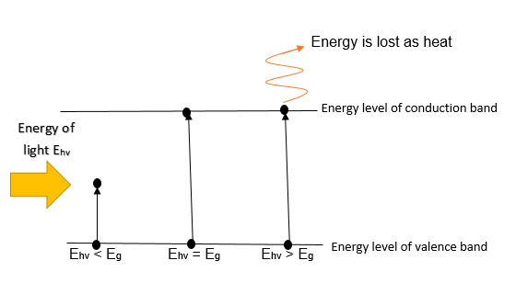

Figure 1: Photovoltaic effect

*Ehv < Eg : The incident light is transparent.*

*Ehv = Eg : Photon is absorbed and its total energy Ehv is transmitted to the electron to overcome the band gap energy Eg.*

*Ehv > Eg : Photon is absorbed and a part of its energy Ehv is transmitted to the electron to overcome the band gap energy Eg. The rest of the energy Ehv is lost as heat.*

Solar cells can be modelled as a current source in parallel with a diode, forcing the current to travel only in one direction (Tobnaghi et al. 2013). The internal resistance can be modelled with series resistors and shunt resistors (Figure 2). Both resistance are temperature dependence but their effects are negligible compared to the dependency described in the next paragraph (Singh & Ravindra 2012).

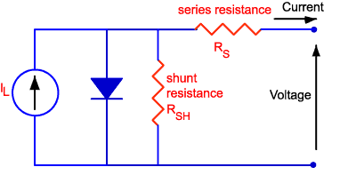

Figure 2: Solar cell model

*A current source in parallel to a diode is often used for solar cell models. The solar cell resistance is modelled as series and shunt resistor.*

*Source: (Honsberg & Bowden 2015)*

The maximum generated voltage by the solar cell is called open-circuit voltage VOC (positive and negative terminals are not connected). In contrast the maximum generated current is called short-circuit current (terminals are short-circuited). Most affected by the increase of the temperature is the open-circuit voltage whereas the short-circuit current in fact increases slightly (Figure 3).

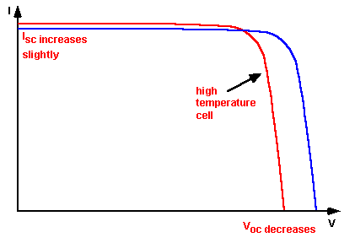

Figure 3: Current-voltage-curve (I-V curve)

*The graph describes the relation between the produced voltage and current of a solar cell (blue line) and how this characteristic curve changes when the solar cell is warmed up (red line).*

Source: (Honsberg & Stuart 2015)

If the temperature in the solar cell rises, the energy of the electrons in the valence band increases according to the band model of a semiconductor (Figure 4). Therefore the electrons are a little bit higher and the band gap decreases. Lower band gap increases the intrinsic carrier concentration ni of the solar cell (Tobnaghi et al. 2013). ni describes the number of holes in the valence band or the number of electrons in the conduction band. ni however increases the reverse saturated current Io , which is a flow reverse the desired hole and electron separation flow (Tobnaghi et al. 2013). Finally this flow decreases the open-circuit voltage in a warm solar cell (Tobnaghi et al. 2013). The following equations describe the relation mathematically (Singh & Ravindra 2012) (Honsberg & Stuart 2015) (Tobnaghi et al. 2013).

$$V_{0C}=\frac{kT}{q}\ln\left(\frac{I_{SC}}{I_{O}}\right)$$

$$I_{0}=qA\frac{Dn_{i}^{2}}{LN_{D}}$$

$$n_{i}^{2}=4{\left(\frac{2πkT}{h^{2}}\right)}^{3}{\left(m_{e}m_{h}\right)}^{\frac{3}{2}}\exp\left(-\frac{E_{GO}}{kT}\right)$$

$$q :electronic charge D :diffusivity of the minority carrier N_{D} :Doping$$

$L :diffusion length of the minority carrier I_{SC} : short-circuit current$

$n_{i} :intrinsic carrier concentration E_{GO} :band gab energy$

$$T :Temperature B, h and k :constants$$

$$I_{0} : reverse saturated current A :cross-section area$$

$$m_{e} and m_{h} are the effective masses of electrons and holes respectively$$

Formula 1: Mathematical description of temperature dependency

*Source: (Singh & Ravindra 2012) (Honsberg & Stuart 2015) (Tobnaghi et al. 2013)*

Most of the other values are also temperature dependence but I0 and ni are the most significant ones (Tobnaghi et al. 2013). Assuming all other variables are temperature independent, an increase of 0.0006 mA and decrease of 2.2 mV per 1 °C drop were calculated for silicon solar cells (Tobnaghi et al. 2013). Overall the power output of the solar cell will change of 0.4-0.5% for every temperature change of 1 °C (Zondag 2008).

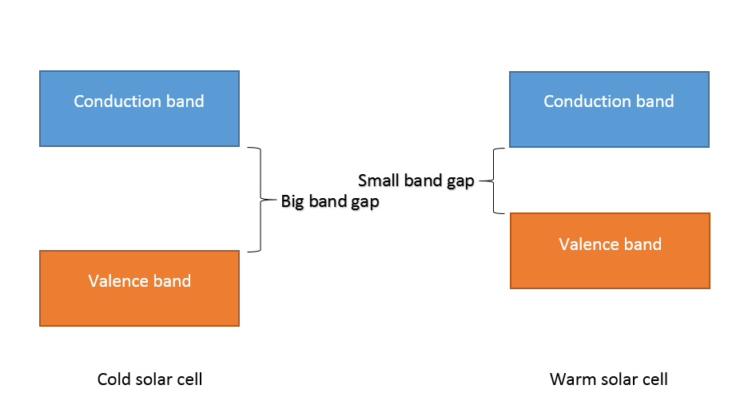

Figure 4: Band model of semiconductors

*The band model of semiconductors predicts that the band gap of warm solar cells is reduced.*

## 2.2. Significant of study

The proportion of PV cell systems is growing in most countries due to the key role it is projected to play in hitting the climate goals such as the 20 % CO2 reduction target by 2020 of the European Union compared to the 1990 baseline (EU Climate Action Program 2015). It is predicted that approaching greenhouse gas targets and governmental subsidies schemes (e.g. Feed in Tariffs) will expedite PV cell technology in the future. Furthermore potable water scarcity, due to population growth and industrialisation, has to be tackled by many countries in the warm, tropical climate zone. Especially the regions with abundant solar radiation often struggle to provide fresh and potable water such as Spain. The shortage in potable water leads to an energy-intensive water treatment industry. All future predictions have in common that this scarcity of pure water will increase due to climate change and exhaustion of natural fossil water resources.

“Sunshine and Shower” will tackle these two major problems at once by increasing the energy generation of the solar cells and providing an environmental friendly option for water treatment compared to the often industrialised energy-intensive desalination plants.

For many countries, the “Sunshine and Shower” technology has the potential to improve their carbon footprint by making renewable energy more efficient and also relieving the energy-intensive water treatment sector.

Particularly in many rural, undeveloped areas whereby no grid or fresh water is locally installed, PV cells are the only practical option to provide the population with energy. If these systems are additionally equipped with “Sunshine and Shower” units, then this will contribute to the millennium goal aims. With regards to applications in this field, many official and government bodies are willing to invest and support further research in this area.

## 2.3. Originality of study

The general principle of a combined cooling and distillation system has been already investigated through computer simulations in the literature and its potential was highlighted (Mittelman et al. 2009). Nonetheless it has never been attempted to build the experimental counterpart so far or optimise the system regarding this application area. This dissertation will fill this gap and provide the experimental evidence of the feasibility, which is crucial for any further development of a prototype system. The dissertation stands out from most other papers, because it considers both sides of the coin equally.

There are already water purifying systems on base of PV cells on the market such as Desolenator (William et al. 2015), but they use the whole heat and electricity yield only for the distillation process. The whole Desolenator product has to be bought at once, which makes it with 1430 Dh (254 pounds) quite expensive for undeveloped countries (The National Business 2014). The “Sunshine and Shower” system stands out from this application, because it improves already existing PV cell installations and provides fresh water for free. The additional generated electricity is therefore kept in its more valuable energy formed and not converted into heat.

The dissertation is unique in its approach, because it analysis the performance of an attachable cooling system rather than an already premade PV/T module. The derived experimental results are therefore significant for any retrofit considerations of PV cells. It is also intended to develop the system as a retrofit efficiency improvement device, which makes it more affordable for developed countries, because the PV cells are not included in the price anymore.

# 3. Scope of the project

3.1. Research aim  
  
This research aimed to develop an attachable cooling and distillation unit to improve the efficiency of photovoltaic (PV) cells and simultaneously purify water in warm climate conditions.

## 3.2. Objectives

Milestone 1 - Setup of the experiment

Developing a cooling circuit consisting of a coiling coil, pump and water flow temperature sensors. Simulation of the solar irritation through lamps and gathering significant physical parameters of the solar cell such as voltage and current output as well as solar cell temperature during irritation.

Milestone 2 - Atomisation of the experiment

Atomisation of the measuring circuit throughout an Arduino board. Setup a serial communication line to the pump and control the lamps through relays attachable to the Arduino board. Preparing the computer environment for a remote control of the whole experiment.

Milestone 3 - Determination of the consisting problem

Investigation of the correlation between temperature rise and power output drop in the solar cell. Gathering and analysing of the solar cell behaviour under different temperature conditions and how a cooling unit can mitigate this effect.

Milestone 4 - Optimisation of the cooling unit

Detailed Investigation of the expected power harvest and temperature recovery of different flow rates. Recommendation for improvements and comparison with the theoretical expected values from the literature.

Milestone 5 - Proof of concept and feasibility study

Scaling up the system to solar module panel size and determination of the break-even point. Critical discussion of the feasibility of the proposed design and size. Recommendations of additional features and expansions of the project to improve its efficiency.

## 3.3. Limitations

The whole project is split into two parts, whereby this dissertation will cover the experimental proof of concept of the cooling unit while the theoretical discussions will be dealt by Gaoyuan Wang (fellow student). Due to climate conditions in the UK, it was agreed to set up a miniature system of the cooling unit inside the lab. On the one hand this provides controllable surrounding conditions as close as possible to a warm climate on the other hand the typical variability of the outdoor environment is missing such as wind or dust influences. It is also not possible to simulate every environmental compound in the lab such as the daily solar movement. The gathered data of the experiment will describe only the output at a specific point of time and date and will not include the daily or annual variation of the environment. Hence the experiment can only provide reliable results if the pre-set lab environment is similar to the prevailing outdoor condition. The system is minimized on base of the current knowledge, it is therefore always possible that an expansion of knowledge will reveal parameters or effects which are significant for the application outside the lab but have not been simulated in the lab environment.

The miniature solar cell of 306 x 218 mm2 surface area is also a limitation due to its structural composition. Commercial-scale modules are often thicker and protected against damage from the backside, which impedes the heat transfer. It is also more than likely that commercial-scale modules are wired up differently due to their greater current and voltage output. Hence their electrical performance is not totally equivalent to the miniature solar cell.

# 4. Literature review

## 4.1. Cooling unit

Solar modules can be separated into two types of generation: thermal solar collectors (T) to generate heat, and photovoltaic systems (PV) to generate electricity. Since a few years, there are also combined modules (PV/T) available. The combined extraction in a PV/T module instead of a separated T and PV module leads to an overall area reduction of 25 % and an initial investment saving of 6 % as the study conducted by Bakker in Holland shows (Bakker et al. 2005). Therefore PV/T cells are preferred for the “Sunshine and Showers” application instead of two separate photovoltaic and thermal cells.

Solar cells have a characteristic I-V curve as seen in Figure 5. This curve is influenced by numerous factors such as the solar cell temperature (2.1. Background).

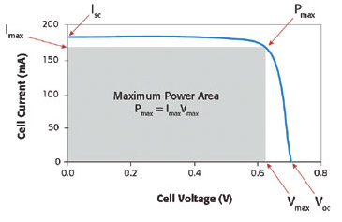

Figure 5: Maximum power point

*The graph describes the relation between the produced voltage and current of a solar cell (blue line). The maximum generated voltage is called open-circuit voltage (positive and negative terminal are not connected) and the maximum generated current is called short-circuit current (terminals are short-circuited). The point on the curve with maximum power generation is called maximum power point.*

*Source: (Keithley Instruments Inc 2015)*

The open circuit voltage (VOC) is the highest possible voltage value which can be produced by the solar cell and the short circuit current (ISC) is the highest possible current value which can be produced. It is not possible to withdraw very high voltage and current at the same time from the solar cell. Due to this correlation, it is vital to operate the solar cell as close as possible to the optimal power point. In other words, the product between the voltage and current is optimal at the maximum power output point, which can be seen graphically as maximum power area in the Figure 5.

Solar cell producers determine this characteristic values under quite precise “standard” test conditions (Figure 6), which are set to a solar irradiation of 1000 W/m2 , a temperature of 25 °C and an air mass of AM 1.5 (Singh & Ravindra 2012). The air mass describes the spectral distribution of the solar light under outdoor conditions at a specific point on the earth surface. The physical principle behind it, is based on the fact that high energy light (small wavelength) are more likely to be scattered by the atmospheric molecules. In general at higher latitude or during sunset, the amount of infrared light (low energy light) increases, due to the longer atmospheric path the light has to travel through the atmosphere.

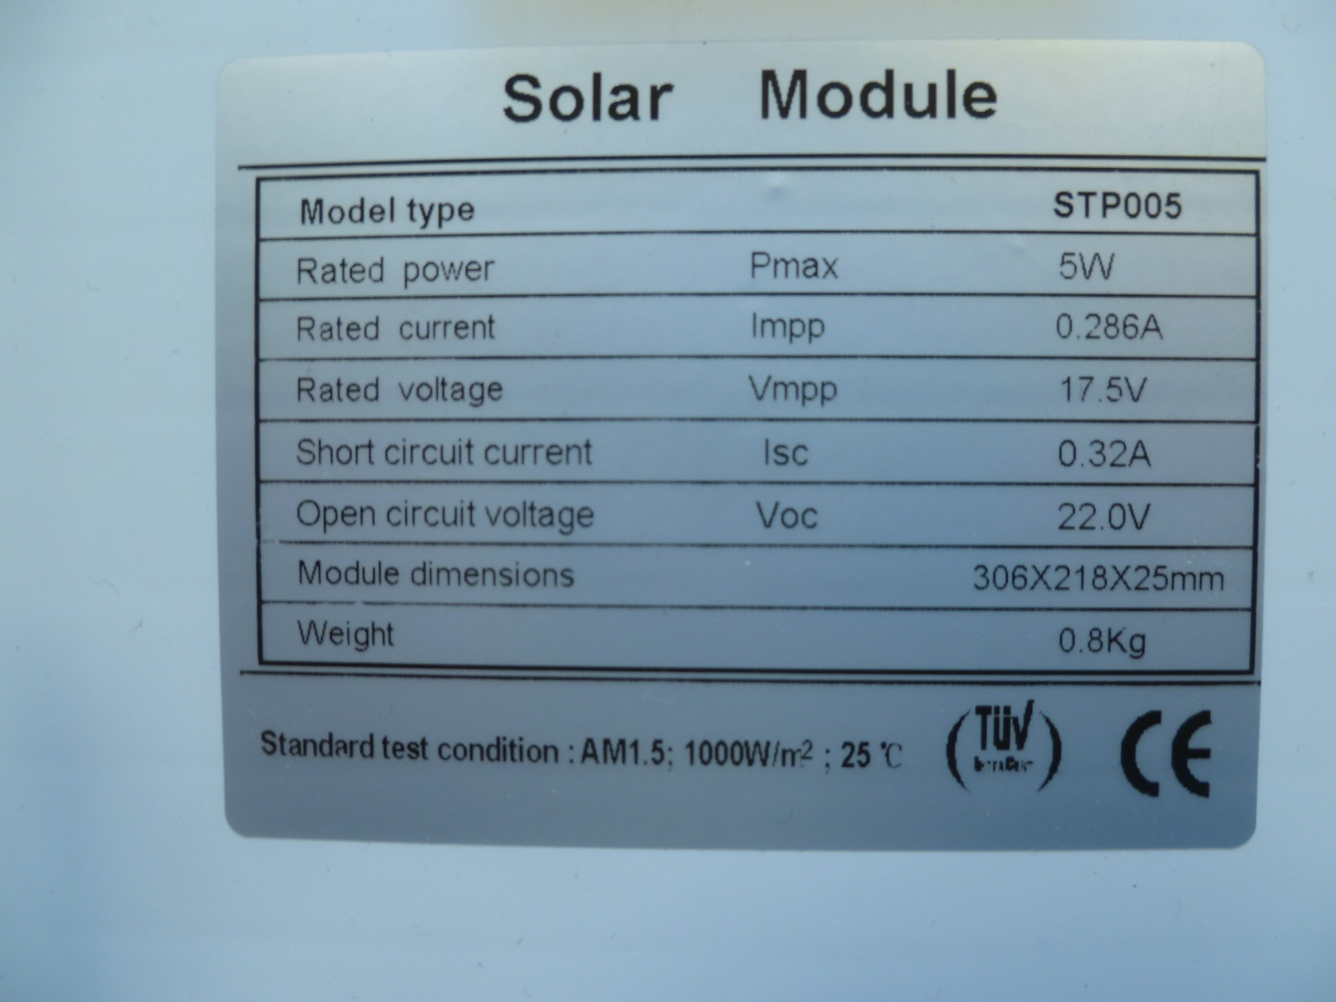

Figure 6: Standard test conditions

*Sticker at the back of the solar cell describes its characteristic values.*

The conversion of light into electricity in a PV cell is not perfect due to band-gap of silicon, which absorbs photons of about a wavelength of 1100 nm and converts them into electricity whereas most of the energy of shorter-wavelength photons is lost as vibration. This effectiveness of conversion is expressed in the term ‘efficiency’, which is in general a measurement for the useful energy output of a system in relation to its total energy output (Formula 2). The solar cell’s electricity efficiency is the percentage of irradiated energy converted to electricity and can be determined as follows (Formula 3).

$$ɳ=\frac{Useful_Energy_Output}{Total_Energy_Output}$$

Formula 2: Efficiency

$$ɳ=\frac{P_{max}}{G*A_{solar_cell}}$$

$$ɳ :Efficiency P :maximal power point \left(W\right) G :irradiance\left(\frac{W}{m^{2}}\right)$$

$$A_{sola_cell} :surface area of solar cell (m^{2})$$

Formula 3: Electrical efficiency of solar cell

The solar cell [manufacturer](http://www.dict.cc/englisch-deutsch/manufacturer.html) gives electricity efficiency value of most commercial silicon-based PV cells of around 6–16 % at standard test conditions (Zondag 2008). But in operational mode this value will change by 0.4–0.5 % for every 1 °C PV cell temperature change (Zondag 2008). As a consequence, the power output correlates linear to the solar cell temperature as seen in Diagram 1. The statements are based on the following formula.

$$ɳ_{electrical}=ɳ_{electrical_standard_condition}∙(1-β\left(t_{solar_cell}-25\right))$$

$$ɳ_{electrical} :electrical efficiency of solar cell$$ $t_{solar_cell} :temperature of solar cell$ $ɳ_{electrical_standard_condition }:electrical efficiency under standard test conditions$ $β :temperature power coefficient of PV cell (material constant)$

Formula 4: Temperature - efficiency correlation

*Source: (Zondag 2008)*

Diagram 1: Theoretical temperature

*Theoretical expected correlation of a 5 W rated solar cell between the power output and solar cell temperature after simplifying the correlation as described in (2.1. Background) to a linear 0.5 % decrease in efficiency for every 1 °C increase* (Zondag 2008)*.*

$$P= -0.025∙\left(T_{solar_cell_temperature}-25\right) +5$$

$$P = -0.025 ∙T_{solar_cell_temperature}+ 5.62$$

Formula 5: Theoretical temperature - power equation

Due to the cells alignment in series, the weakest cell will determine the power output of the whole solar module (Dolara et al. 2013). Depending on the exact wired up setup, not every part of the solar module has the same influence on the overall power output of the solar module. For example the right bottom solar cell in Figure 7 can reduce the output as much as the whole column. Modern solar modules are therefore sometimes equipped with bypass diodes, which allow bypassing the weakest solar cells if necessary (Dolara et al. 2013). It is reasonable to consider this internal setup of the solar module in the context of solar cell cooling, because the cooling process will introduce an uneven temperature distribution and hence some solar cells will be weaker than others.

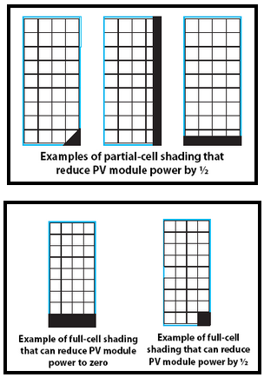

Figure 7: Partial-shading of solar cells

*Because the solar cells are aligned inside the module in series to increase the voltage output, partial- or full-cell shading of small parts can affect the overall power output dramatically.*

*Source: (SolarTaos 2015)*

Inspired by leaves, the most efficient PV cells ever developed, scientist started to copy the under the leaf existing cooling mechanism with evaporate matrices. This setup leads to an electricity output increase of about 5.2 - 6.6 % (Šuklje et al. 2013). Also closed water and air cycle systems were developed for areas with scarce water supply. In general, most fluids have a greater heat capacity than air and are therefore preferred for cooling applications (Abdul Hamid et al. 2014). However air systems can also be operated at regions with freezing temperatures, but because the application area of “Sunshine and Shower” will be in a warm climate with low altitude, it is not necessary to use an air system (Abdul Hamid et al. 2014).

Because the heat generation is not uniform in a PV cell Ibrahim et al. simulated seven different closed water cycle absorbers under a flat plate thermal collector to determine the best design (Ibrahim et al. 2009). The highest thermal efficiency of 50.12 % and corresponding electricity efficiency of 11.98 % were observed by the spiral design (Figure 8e) under the fixed conditions of solar radiation of 600 W/m2 and fluid flow rate of 0.01 kg/s.

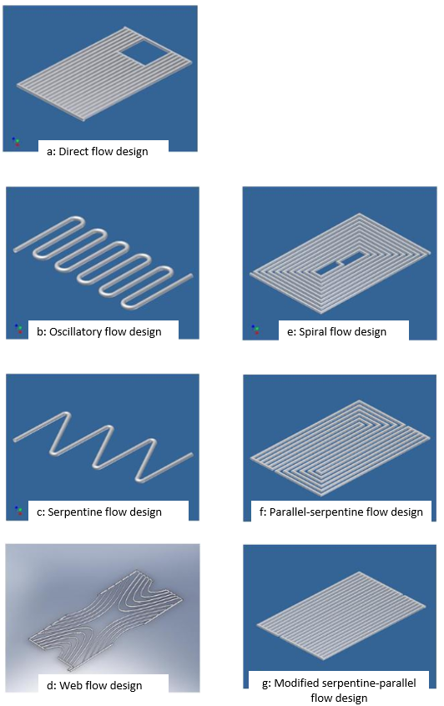

Figure 8: Different absorber tube designs

*Different absorber tube designs were simulated to identify the optimal cooling coil design. The seven depicted designs were investigated in the paper.*

*Source: (Ibrahim et al. 2009)*

## 4.2. Distillation unit

Single slope solar still distillation units meet WHO guidelines for drinking water quality as studies in rural areas demonstrate (Jasrotia et al. 2012). Their investment cost is less than 25 pounds (Flendrig et al. 2009), but their heat into purified water conversion is with 39 % not so efficient (Flendrig et al. 2009). Overall a quite huge surface area of 1.34 m2 is needed to produce 3 l/day fresh water at an irradiation of 12.95 MJ/day/m2 (Flendrig et al. 2009). Different additional equipment enhance the productivity up to 51-148 % (Eltawil & Omara 2014). This includes spraying units, water fountains inlet, circulated hot water, external condenser and bottom released preheated air bubbles to lower the surface tension of the water.

Kalidasa developed a theoretical model of a single basin double slope solar still and estimated an average daily production of 2.1 l/m2 for a local area in India (Kulandaivel & Kapruppiah 2014). The model was then verified with an overall correlation coefficient of 0.921 by an actual field experiment (Kulandaivel & Kapruppiah 2014).

The freshwater production can also be increased by adding more condensation chambers. Studies with seawater revealed an increase of over 100 % by adding 3 additional stages from 11.96 to 22.81 kg/m2 and from 12.40 to 27.48 kg/m2 in different operational modes (Karimi Estahbanati et al. 2014).

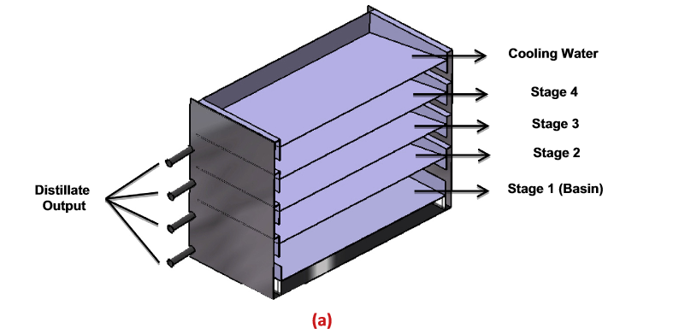

Figure 9: Multi condensation chamber design of distillation unit

*The figure shows a distillation unit with several condensation chambers to improve its efficiency.*

*Source: (Karimi Estahbanati et al. 2014)*

Experiments with varying the water depths in the water basin conclude a strong inversely proportional connection between evaporation rate and depth of water (Muthu Manokar et al. 2014).

# 5. Description of the experimental setup of the cooling unit

The “Sunshine and Shower” system consisted of a closed water cycle unit, which was attached underneath the solar panel and operated by a REGLO-CPF digital pump. The simulated heat concentration in the middle of the PV panel was the reason to choose a spiral cooling coil design (Ibrahim et al. 2009). Due to the pre-mounted cable connection box, it was not possible to cover the whole back with the cooling coil. Hence, 1/3 of the solar cell is not exposed to the cooling effect. This limitation will be discussed in more detail in chapter 8.2. Analysis and interpretation. A metal plate was mounted on the coiling coil to increase the contact area of the heat transfer (Figure 12). Also a thin layer of Servisol heat sink compound (non-silicone) between metal plate and solar cell improved the conductivity. Two inflow thermocouples captured the temperature directly at the in- and outflow of the cooling coil. In addition, the temperature of the solar cell was logged on both sides with thermocouples. All data was collected by an Arduino UNO board and reported to the connected computer. Two 150 W lamps were mounted at a distance of 12 cm and provided the irradiation as well as functioned as heat source. Although a heat exchanger belongs to the cooling unit design, it was not included in these proof-of-concept experiments.

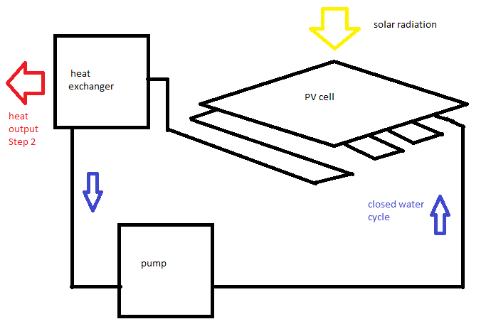

Figure 10: Basic operation graph of the cooling unit design

*A closed water cooling cycle is operated by a pump. The heat exchanger will be introduced in the future to provide the required heat for the distillation unit.*

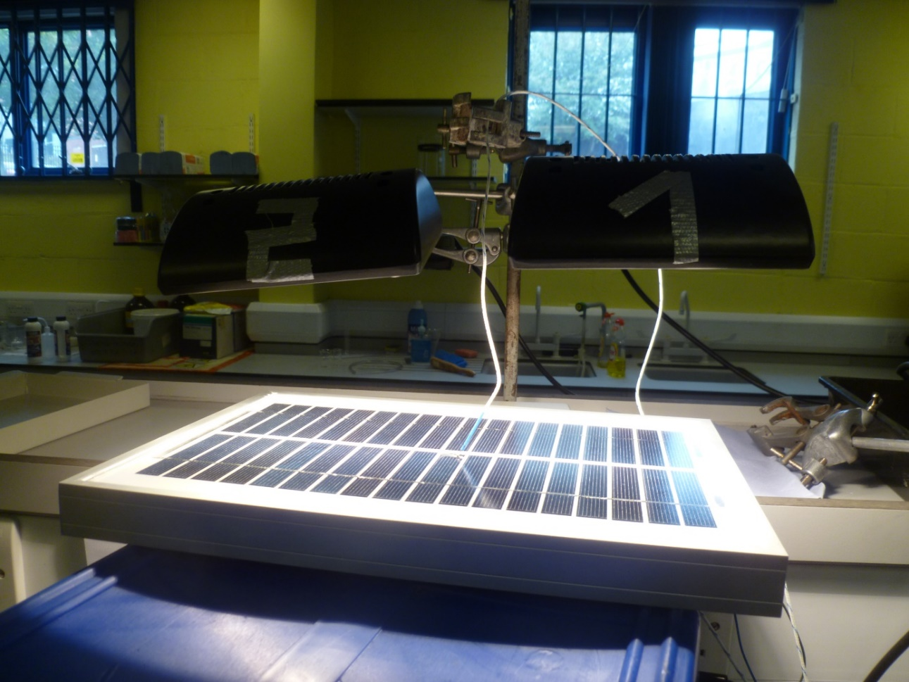

Figure 11: Lamps and solar cell

*The lamps were mounted 12 cm above the solar cell and simulated the solar irradiation as well as the heat generation. A thermocouple was measuring the top temperature of the solar cell (11.4.7. Thermocouples).*

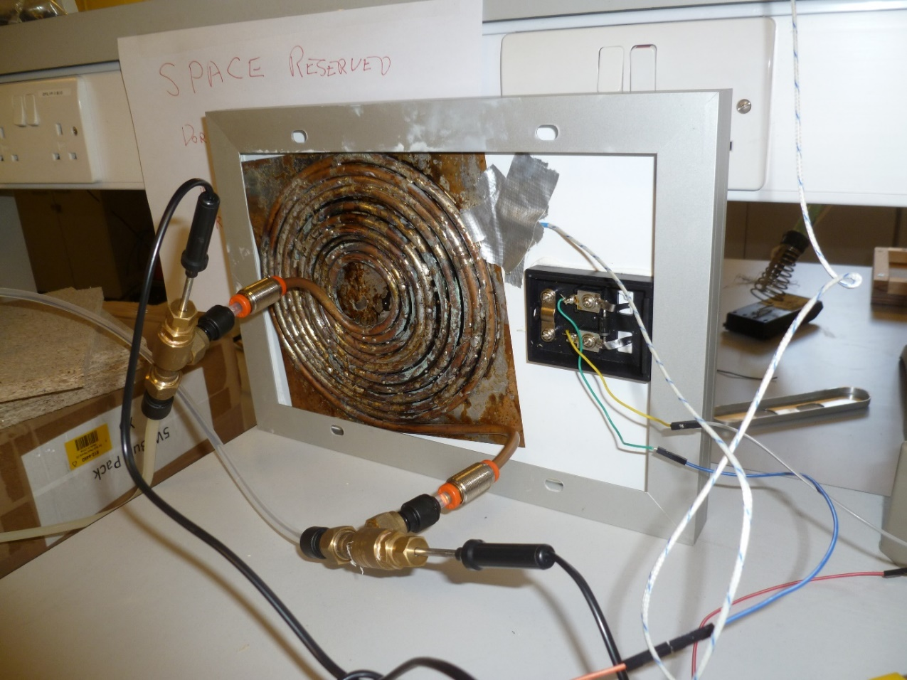

Figure 12: Cooling coil under the solar cell and flow temperature sensors

*The cooling coil could not cover the whole back of the solar cell due to the terminal connections of the solar cell. It was welted on a metal absorber plate. Two flow temperature sensors measured the inflow and outflow temperature (red circle) and a thermocouple attached to the bottom of the solar cell measured the solar cell temperature (green circle).*

# **6. Description of the proposed setup of the distillation unit**

The second part of the “Sunshine and Shower” system is a distillation unit, which uses the extracted warm water from the cooling unit by concentrating the heat throughout a heat pump.

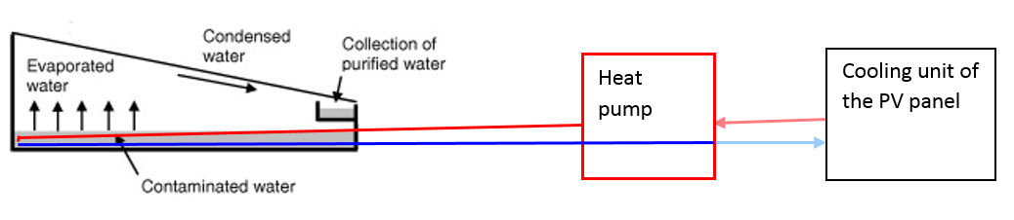

Figure 13: Distillation system with energy input through a heat pump

*Basic operation graph of the proposed distillation unit and its connection to the cooling unit.*

*Source: (Flendrig et al. 2009)*

# 7. Methodology

## 7.1. Description of the cooling and heating experiment

### 7.1.1. Justification for the implementation of the experiment

First of all, the dependence of the power output on the solar cell temperature should be investigated. It is reasonable to verify this basic correlation experimentally to justify the operation of the cooling unit.

### 7.1.2. Determination of the constants and altering variables

It was not practical to directly alter the solar cell temperature. This variable was therefore altered indirectly through cooling with the “Sunshine and Shower” unit or heating with the lamps. It was decided to use the cooling unit because it introduced a slower temperature change in the solar cell than the switching on/off process of the lamps. As a consequence, more data points could be gathered during the temperature change period. The solar cell temperature was logged with a thermocouple on the top and bottom of the solar cell. The current and voltage values were measured as variables of interest. The lamps were always switched on.

### 7.1.3. Condition of the system during data collection

Cooling experiment

|  |  |  |  |  |
| --- | --- | --- | --- | --- |
| Steady state point at the start | Data collection:  bottom and top temperature of solar cell, current and voltage | | | Steady state point at the end |
|  | | | | |
| pump | | | | |
| off | on | on | on | on |
|  | | | | |
| lamps | | | | |
| on | on | on | on | on |
|  | | | | |
| solar cell temperature | | | | |
| hot | hot/warm | warm | warm/cool | cool |

Table 1: Cooling experiment - condition of the system

The table describes the condition of the cooling experiment at the beginning, during data collection and towards the end.

Heating experiment

|  |  |  |  |  |
| --- | --- | --- | --- | --- |
| Steady state point at the start | Data collection:  bottom and top temperature of solar cell, current and voltage | | | Steady state point at the end |
|  | | | | |
| pump | | | | |
| on | off | off | off | off |
|  | | | | |
| lamps | | | | |
| on | on | on | on | on |
|  | | | | |
| solar cell temperature | | | | |
| cool | cool/warm | warm | warm/hot | hot |

Table 2: Heating experiment - condition of the system

The table describes the condition of the heating experiment at the beginning, during data collection and towards the end.

## 7.2. Description of the flow rate experiment

### 7.2.1. Justification for the implementation of the experiment

The upcoming three experiments will focus on the actual expected power and temperature recovery of three different flow rates. It will provide the base for optimisation of the flow rate. The collected power and harvest value will be consulted to evaluate the feasibility of the system and it will provide the data base to consider the design and performance of the distillation in the future.

### 7.2.2. Determination of the constants and altering variables

The next three experiments should investigate the effects of different flow rates. Therefore the flow rate was set in the first, second and third experiment to 36 ml/min, 26 ml/min and 16 ml/min, respectively.

The water temperature was equalised through the volume of the water bucket as well as the pump (worked as heat sink) before it was re-introduced in the cooling coil.

All six sensor values were stored (top and bottom temperature of solar cell, inlet and outlet temperature of the water and current and voltage of the solar cell).

### 7.2.3. Condition of the system during data collection

|  |  |  |  |  |
| --- | --- | --- | --- | --- |
| Steady state point at the start | Data collection:  bottom and top temperature of solar cell, current and voltage | | | Steady state point at the end |
|  | | | | |
| Pump (flow rate: 36 ml/min, 26 ml/min or 16 ml/min) | | | | |
| off | on | on | on | on |
|  | | | | |
| lamps | | | | |
| on | on | on | on | on |
|  | | | | |
| solar cell temperature | | | | |
| hot | hot/warm | warm | warm/cool | cool |

Table 1: Flow rate experiments – condition of the system

The table describes the condition of the flow rate experiments at the beginning, during data collection and towards the end.

## 7.3. Calibration, accuracy and precision of the measurements

In general, the precision of the measurements will be improved by calculating the average over several measurements whereas the precision will be increased through correction factors in the programming code.

### 7.3.1. Temperature measurement

The temperature was measured with thermocouples, which have only a precision of about +/- 2 °C (Thermocouple Amplifier DataSheet 2015).

Due to the circumstance, that the thermocouples are not calibrated against an accurate thermometer (11.4.7. Thermocouples), the worst case scenario was selected by choosing the thermocouple for the inlet temperature measurement, which tends to show a higher value than the outlet thermocouple. Thus, the difference between outlet and inlet temperature is equal or smaller than the exact value. It is therefore important not to change the direction of flow in all 3 flow rate experiments.

### 7.3.2. Voltage and current measurement

The original precision of the current sensor was with 0.0263 A per unit reading definitive too low for an application in the experiment (11.4.4. Current measurement). The measurement range and output range of the sensor was changed completely to adjust the sensor for this purposes (Table 21). This calibration step increased the precision of the sensor to 0.0014 A per unit reading with an analogous reference value of 5 V or 0.0003 A per unit reading with an analogous reference value of 1.1 V (11.4.5. Analog reference value and 11.4.4. Current measurement). The precision of the current measurement can be further increase through changing the analogous reference value to 1.1 V in the future (11.4.4. Current measurement).

The current was determined very precise due to its critical effect on the power output. Overall a small error in the current measurement adulterate the power output more than a small error in the voltage measurement. It was therefore decided that only a correction factor at the current measurement is necessary.

Due to other components in the measurement circuit such as resistors, an additional correction factor of 0.15 was added to the current measured values. The exact correction factor was derived through calibration against a three-digit ammeter.

The solar cell produces the most power at the maximum power output point (Figure 5). The introduced load should be selected to operate the solar cell at this maximum power output point.

Due to the 5 W power output of the solar cell, it is not advised to use standard resistors, because they will warm up and change their resistance, which leads to an adulteration of the measurement. Instead power resistors are recommended, due to the greater surface area, which can disperse the generated heat better. Three 10 W power resistors with 22 Ω resistance were wired up in series to simulate the load in the measurement circuit. The combined resistance of 66 Ω is close enough to the optimal resistance of 61.19 Ω (11.4.3. Introducing power resistors as load in the measurement circuit).

## 7.4. Control over environmental variables

### 7.4.1. Ambient temperature and wind

The experiment had the advantage to be setup in a lab environment. Consequently a constant ambient temperature of 20 °C could be achieved due to the air conditioning. The ventilation was switched off during the experiment to neglect any wind effects.

### 7.4.2. Scattered light

Each data point includes the time and date when it was collected. This time information can be linked to the lab environment such as room lighting, which will be likely switched off during the night or on weekends. Nonetheless I was present in the lab for the duration of data collection to ensure that the surrounding light is constantly switched on.

## 7.5. Location of the sensors in the experiment

Many of the experimental results will be explained by the sensor positioning (8. Presentation, analysis and interpretation of the data). A detailed description of their implementation in the experiment will be carried out in the following paragraph together with an explanation of the existing constraints and theoretical consideration leading to this setup.

The flow temperature sensors were mounted inside a metal structure only 1 cm away from the cooling coil inlet and outlet. The temperature measurement point was in the middle of the water flow.

The thermocouple at the bottom of the solar cell was mounted at a distance of 5 mm away from the edge of the absorber plate. It is therefore exposed to the cooling effect but cannot mitigate the heat transfer between absorber plate and solar cell, which should be as tight together as possible. The thermocouple on the top of the solar cell was in contact with the glass cover, but not secured with duct tape due to its shading effect on the solar cell. The sensor was located directly above the middle of the cooling coil and hence exposed to the maximal cooling effect. The voltage and current measurement have to be conducted in one combined measurement circuit (11.4.6. Combined current and voltage measurement circuit) to avoid a separation of the current between the two circuits (parallel circuit). This setup also allows applying the same load resistor to both sensors.

## 13.6. Determination of the steady state points

It was crucial to determine the steady state point (heat equilibrium is achieved) as precise as possible in all experiments. The values of the flow temperature sensors were observed for at least 5 minutes and if no more than 2 °C temperature change could be observed during this time, it was assumed that the steady state point was reached. This long waiting period was necessary to allow the power output achieve the steady state point as well (8.2.2.2. Time duration results). Nevertheless a real steady state point was only reached after several hours/ nearly a day, but there were no practical method available to determine this state, especially because the steady state point could change from day to day slightly (e.g. sunny or cloudy day)(11.3. Regression analysis).

## 7.7. Data gathering procedure and data storage

The average of 10 measurements were calculated by the Arduino board every second (50 measurements for the current). This average was stored as one date point. Overall more than 2000 data points are shown in the Cooling Experiment diagrams (Diagram 2 and Diagram 3) and 1157 data points in the Heating Experiment diagrams (Diagram 4 and Diagram 5).

The current was determined very precise due to its critical effect on the power output. Overall a small error in the current measurement adulterate the power output more than a small error in the voltage measurement.

Since the condition of the pump such as the flow direction (7.3.1. Temperature measurement) can also influence the data output, it was mandatory to store these pump conditions together with the collected data. Hence, each date point was equipped with the current set flow rate of the pump (stored in mantissa and exponent e.g. the flow rate 36 ml/min is stored as 3600, -2) and the direction of flow (1 indicates clockwise flow and 0 indicates anticlockwise flow).

# 8. Presentation, analysis and interpretation of the data

## 8.1. Presentation of the data

### 8.1.1. Cooling and heating experiment

The collected solar cell temperature is presented against the power output of the solar cell in a scatter diagram. Four different diagrams are presented to compare the cooling and heating experiment as well as the bottom and top temperature sensor.

Diagrams of the cooling experiment through switching off the pump:

Time

Diagram 2: Cooling experiment - top temperature sensor

*The top solar cell temperature is shown against the power output of the solar cell, which was continuous cooled down in the experiment.*

Time

Diagram 3: Cooling experiment - bottom temperature sensor

*The bottom solar cell temperature is shown against the power output of the solar cell, which was continuous cooled down in the experiment.*

Diagrams of the heating experiment through switching on the pump:

Diagram 4: Heating experiment - top temperature sensor

*The top solar cell temperature is shown against the power output of the solar cell, which was continuous heated up in the experiment.*

Time

Diagram 5: Heating experiment - bottom temperature sensor

*The bottom solar cell temperature is shown against the power output of the solar cell, which was continuous heated up in the experiment.*

### 8.1.2. Flow rate experiments

The experiment is very sensitive regarding the starting conditions and it is nearly impossible to start all three experiments under exact the same circumstances (same solar cell temperature, similar and uniformly heat distribution in the water tube). Especially because the steady state point can only be achieved after a whole day and it always varies. Nonetheless it is vital to find a common base, which allows comparing the data. As a result, the data point, which reaches 75 °C for the first time on the top solar cell, was selected to be the first second in the following diagrams. This decision has the effect, that even if one experiment started with higher solar cell temperature, at the first second of the diagram all three experiments will have nearly the same power harvest and temperature recovery, because the solar cell has exact the same temperature. 75 °C is slightly under the steady state temperature of around 80 °C at the beginning of the experiment, so that the whole cooling process can still be observed. It is now also possible to compare the flow rates regarding the time they need to cool down the solar cell.

All six collected parameters can’t be shown in the same diagram in a clear and coherent manner. Hence, they are separated in three interest groups the solar cell temperature (Diagram 9), power output (current and voltage of solar cell; Diagram 6 and Diagram 7) and temperature recovery (in- and outlet temperature of the water; Diagram 8). The solar cell temperature is shown against the elapsed time since the beginning of the experiment in Diagram 9. The power output of the solar cell is shown against the elapsed time since the beginning of the experiment in Diagram 6 and Diagram 7. The recovered heat is shown against the elapsed time since the beginning of the experiment in Diagram 8. This common time base allows the comparison of the data in the different diagrams.

The data points in the power harvest diagram are overlapping most of the time. Therefore two different versions were produced, so that in one diagram the lower flow rates are in the foreground and in the other diagram the higher ones. This arrangement makes it clearer to assess the overall spatial positioning of the different flow rates to each other.

Diagram 6: Power harvest for different flow rates 1

*The graph shows how the different flowrates 36 ml/min, 26 ml/min and 16 ml/min influence the power output of the solar cell over time. The solar had a very high temperature at the beginning of the experiment, so that the cooling effect of the flow rates can easily be observed.*

Diagram 7: Power harvest for different flow rates 2

*The graph shows how the different flowrates 36 ml/min, 26 ml/min and 16ml/min influence the power output of the solar cell over time. The solar had a very high temperature at the beginning of the experiment, so that the cooling effect of the flow rates can easily be observed.*

Diagram 8: Temperature recovery for different flow rates

*The graph shows how the different flow rates 36 ml/min, 26 ml/min and 16ml/min influence the temperature recovery over time. The solar had a very high temperature at the beginning of the experiment, so that the cooling effect of the flow rates can easily be observed*

Diagram 9: Cooling process of the solar cell

*The graph shows how the different flow rates 36 ml/min, 26 ml/min and 16 ml/min influence the solar cell temperature over time. The solar had a very high temperature at the beginning of the experiment, so that the cooling effect of the flow rates can easily be observed*

## 8.2. Analysis and interpretation

### 8.2.1. Cooling and heating experiment

#### 8.2.1.1. Results

A strong relationship can be observed. All experiments showed that a higher temperature will decrease the power output of the solar cell. On average the pump is able to cool down the solar cell of about 20 °C in a very short period of time (an hour). After several hours / nearly one day, the pump reduces the solar cell temperature at the top of the solar cell of about 30 °C, which seems to be the steady state point. The 20 °C reduce in solar cell temperature correlates with an additional power output of 0.2. That is 6.7 % more power than the original power output value of 3 W. Due to the introduced load resistors, both power values can be interpreted as maximal power points and hence the efficiency of the solar cell also increases of about 6.7 % (Formula 3).

Theoretically the efficiency should change by 0.4 % - 0.5 % for every 1 °C solar cell temperature change (Zondag 2008). This means 8 % - 10 % increase at 20‍‍°C temperature change. The experimental result of 6.7 % is close to this theoretical value of 8 %. Taking into account that the load resistors with 66 Ω were only very close to the optimal value of 61.19 Ω and the power wasted in the Arduino board and measuring circuit, 6.7 % is a realistic output.

#### 8.2.1.2. Break-even point to operate the cooling circuit

The maximum power consumption of the REGLO-CPF pump is 50 W (Ismatic 2015). Based on the selected flow rate, it is presumed that this value is actually reached by the pump. Such power consumption is obvious out of range to be balanced out in the conducted experiment. As a consequence, the whole system has to be scaled up to solar panel size. Assuming the original power output without cooling was 3 W then by analogy to the additional 0.2 W output of the 5 W rated solar cell, common solar modules with 1 m2 surface area and 140 W (Ownergy 2015) rated power should reach an additional output of 5.6 W. Hence the break-even point to operate the pump can be achieved with solar panels covering a surface area of about 9 m2.

**8.2.1.3. Regression analysis**

|  |  |  |  |
| --- | --- | --- | --- |
|  | R2 | Significance F | Number of data points |
| Cooling experiment -  top temperature sensor | 0.915709862 | 0 | 2421 |
| Cooling experiment -  bottom temperature sensor | 0.951702185 | 0 | 2421 |
| Heating experiment -  top temperature sensor | 0.907113606 | 0 | 3089 |
| Heating experiment -  bottom temperature sensor | 0.952890805 | 0 | 3089 |

Table 3: Regression analysis summary

*Summary of the regression analysis of the cooling and heating experiment (11.3. Regression analysis output files).*

The bottom temperature sensor correlates better with the power output than the top temperature sensor in both experiments. Either the electricity producing layer is closer to the back side of the solar cell (thick glazing layer) or the positioning / fixing of this sensor was more appropriate to determine the solar cell temperature (Table 3). The heating experiment has a better R2 value, but it also had 3089 data points instead of 2421 data points available (Table 3).

Cooling experiment - top sensor regression equation:

$$Power= - 0.009861406 ∙ Solar_cell_temperature + 4.000269874$$

Cooling experiment - bottom sensor regression equation:

$$Power = - 0.010214396 ∙ Solar_cell_temperature+ 3.892889354$$

Heating experiment - top sensor regression equation:

$$Power = - 0.01227693 ∙ Solar_cell_temperature + 4.006785522$$

Heating experiment - bottom sensor regression equation:

$$Power = - 0.011761944 ∙ Solar_cell_temperature + 3.975470198$$

Formula 6: Experimental temperature - power output correlation

The slope of the theoretically calculated Diagram 1 is with -0.025 close to the experimental derived slope of around -0.009861406 to -0.01227693. The differences are caused due to the circumstances, that in the experiment 1/3 of the solar cell could not been cooled down. This not cooled part still produces the same amount of energy in the case of a measured solar cell temperature increase or decrease. A measured solar cell temperature change has therefore less effects on the power output in the experiment than in theory and hence the slope is lower.

The mentioned problem of the solar cell alignments in series Figure 7 could not been observed in the data. There are two possible reasons for it. Either the solar cell has bypass diodes, which allow bypassing the weakest internal solar cells (4. Literature review) or, what is more likely, the internal solar cells are not aligned in series due to the low voltage output of the solar cell. In general, the internal solar cells are in series to increase the voltage output of a solar module (Dolara et al. 2013). Nonetheless it will become a reasonable issue during the scaling up process and should be considered.

The y-intercepts of the experimental and theoretical temperature – power output correlation cannot be compared due to the assumption that the solar cell is operated at a solar irradiation of 1000 W/m2 and air mass of AM 1.5 (standard test condition) in Diagram 1, whereas the irradiation condition of the solar cell in cooling and heating experiment is unknown.

The comparison of the cooling and heating experiment among themselves reveals that both ones have nearly exact the same y-intercept, whereas the slope is in the heating experiment lower. The power output must therefore fall faster in the heating experiment. As a result the solar cell in the heating experiment produces less power for every solar cell temperature than the solar cell in the cooling experiment. This behaviour is most likely caused by the different days the experiments were conducted. Although the irradiation of the lab environment (lamps at the ceiling and the two halogen lamps) were constant, it was still solar irradiation coming through the windows. A sunny or cloudy day can likely influence the data, especially because the sunlight has a different spectrum and will fill irradiation gaps, which are not provided by the halogen lamps. The cooling experiment has a quite thinner progression and less data points between the starting and final steady state point, which suggests that the cooling process through the pump happens faster than the heating process in the second experiment.

Because the bottom sensor in the heating experiment showed the best correlation, the standard deviation will be investigated. A standard deviation of 0.015 was calculated and hence the double standard deviation is 0.030. The Diagram 10 shows the regression equation with the data points and the Diagram 11 shows the regression equation with the double standard deviation. It means that 95 % of the data points were between the orange and grey line (Diagram 11).

Diagram 10: Heating Experiment with regression equation

*The solar cell temperature of the bottom temperature sensor is depicted against the power output of the solar cell. The regression line is also depicted.*

Diagram 11: Double standard deviation of the heating experiment

*The regression line from the heating experiment is shown and a double standard deviation of 0.03.*

The steady state point is depicted in both experiments as thick accumulation point, which is sometimes shifted a bit in a different direction than the correlation would suggest. This highlights again, that the steady state point is not so exact defined and sometimes influenced through other effects as well such as slowly cooling of the remaining 1/3 not cooled solar cell or changing resistance in the measurement circuits.

The average between the top and bottom temperature sensor value cannot describe the correlation with the actual temperature of the solar cell as good as the data from only the bottom sensor. The bottom sensor starts first to change its temperature whereas the top temperature is still constant, then both sensors change at a nearly similar rate and towards the end only the top temperature sensor changes its value. This unequal behaviour is the reason for the better performance of the bottom temperature sensor compared to the average value of both sensors. Also a separate regression analysis showed that the bottom sensor has a better correlation (R2 value) than the average between top and bottom sensor. As a result the average was not considered in the discussion of the results anymore.

### 8.2.2. Flow rate experiments

#### 8.2.2.1. Power harvest results (Diagram 6 and Diagram 7)

Small variations in data cause temporary a total overlapping of the different flow rates. On base of the solar cell temperature measurement (Diagram 9), it was derived that over a long period of time the flow rate 36 ml/min will produce indeed more power than 26 ml/min and 26 mil/min more than 16 ml/min accordingly.

The average of the first 60 data points in the Diagram 6 was calculated to verify that we achieved similar starting conditions through the shifting step of the starting point towards the first measurement, which reached less than 76 °C on the top temperature measurement. All flow rates show nearly exact the same power output, which means the shifting process was successful.

|  |  |
| --- | --- |
| Flow rate | Average of the power output  of the 1 - 59 seconds in the diagram |
| 36 ml/min | 3.1231 W |
| 26 ml/min | 3.1205 W |
| 16 ml/min | 3.1296 W |

Table 4: Flow rate and power harvest 1

The average over all data points in the diagram was calculated to determine the flow rate, which harvests the most. The differences are so small that no significant evaluation can be made. Although the power output of the 36 ml/min flow rate is the highest followed by the 26 ml/min one and 16 ml/min one (Table 5). These results are in accordance to the theoretical expected behaviour that a faster flow rate can cool down the solar cell better and hence produces more additional power.

The exact correlation between the flow rate and power harvest cannot be determined with this set of data, because the inaccuracy of the measurements are likely to be higher than the differences observed in these values (8.2.3. Limitations of the data). Probably the 36 ml/min rate also harvests a bit more, because it can cool down the solar cell faster than the other two rates. Hence the differences between the flow rates should be greater in the middle of the experiment during the greatest cooling effects.

|  |  |
| --- | --- |
| Flow rate | Average of the power output  of the 1 - 1156 seconds in the diagram |
| 36 ml/min | 3.1950 W |
| 26 ml/min | 3.1891 W |
| 16 ml/min | 3.1837 W |

Table 5: Flow rate and power harvest 2

A closer look was given to the last 900 - 1000 data points in the Diagram 6 to derive the steady state values. The last few data points were not used, due to the rise of the 36 ml/min data in the last 50 values. This rise can also be observed in the Diagram 7. The cause of this behaviour is probably a random process and therefore not considered anymore, but an inclusion of these few values would adulterate the steady state values.

|  |  |
| --- | --- |
| Flow rate | Average of the power output  of the 900 - 1000 seconds in the diagram |
| 36 ml/min | 3.2186 W |
| 26 ml/min | 3.2131 W |
| 16 ml/min | 3.2086 W |

Table 6: Flow rate and power harvest 3

Assuming the original power output without cooling was 3 Watt. The power output rose of about 7.3 %, 7.1 % and 7 % at a set flow rate of 36 ml/min, 26 ml/min and 16 ml/min, respectively.

Taken into account that at a typical 1 m2 solar module with rated power of 140 W (Ownergy 2015), this means only a difference between 0.28 W to operate the cooling unit with highest or lowest possible flow rate. It is questionable if this can be balanced out by the additional energy needed for the higher pump activity.

The 26 ml/min flow rate experiment and especially the 16 ml/min flow rate experiment, was conducted a lot longer than 1157 seconds to give the experiment more time to reach the steady state point. 2007 seconds were analysed in the 16 ml/min flow rate experiment and 1639 data points in the 26 ml/min flow rate experiment. The following final steady state point power values were derived from the average of the last 100 data points, which were collected in the both experiments.

|  |  |
| --- | --- |
| Flow rate | Average power output  of the last 100 data points |
| 26 ml/min | 3.2109 W |
| 16 ml/min | 3.2026 W |

Table 7: Flow rate and power harvest 4

It is noticeable that the power output vales from Table 7 decreased slightly in relation Table 6 although the opposite would be assumed, due to the still going on cooling process. The explanation for this behaviour is most likely in the measurement circuit itself. The constant power through the load resistors and Arduino board will cause specific elements to heat up and change their resistance slightly. When a cooling process suddenly changes the power flux then also the elements in the circuit will be more or less heated and they can change their resistance. Especially a small change in the resistance of the load resistor can cause significant differences in the power output, due to the load resistors relation to the maximal power output point on the I-V curve (11.4.3. Introducing power resistors as load in the measurement circuit).

#### 8.2.2.2. Time duration results

In accordance to Diagram 9, the solar cell is nearly completely cooled down to the steady state point after only 430 seconds for all flow rates whereas the power output rises even far beyond 430 seconds (Diagram 6 and Diagram 7). This is caused by the thermocouple position, which was directly above the middle of the cooling coil, so that it is optimal exposed to the cooling effect of the coil. Nevertheless it needs more time until the cooling effect is transmitted to other parts of the solar cell, especially to the 1/3 part of the solar cell, which is not mounted above the cooling coil, but maybe also slightly benefits from the cooling effect.

It is obvious that the higher temperature gradient at the beginning of the experiment causes a faster reduction in the solar cell temperature than in the end of the experiment. Especially at a flow rate of 36 ml/min, this reduction happens nearly completely in the first 6 minutes whereas the flow rate 16 ml/min needs about the double amount of time.

In summary the steady state point of the temperature recovery is reached faster than the steady state point of the power harvest for all flow rates.

#### 8.2.2.3. Temperature recovery results (Diagram 8)

The harvest temperature is for all flow rates at the beginning the same. Towards the end, 11 °C, 6 °C and 3.5 °C are harvested by the 16 ml/min, 26 ml/min and 36 ml/min flow rate, respectively. There is obvious no linear correlation between flow rate increase and temperature recovery decrease. An increase of the flow rate of about 10 ml/min leads on the one hand to a decrease of 5 °C and on the other hand of 2.5 °C.

Hypothesis

It is assumed, that the temperature recovery and flow rate are in the following relation, whereas the plateau represents the heat transfer equilibrium. When the water travels slowly enough in the pipe, then it reaches the point where it absorbs as much energy from the solar cell as it releases to the surrounding air. A heat transfer equilibrium exists and the temperature in the water pipe will not increase anymore even with a slower flow rate.

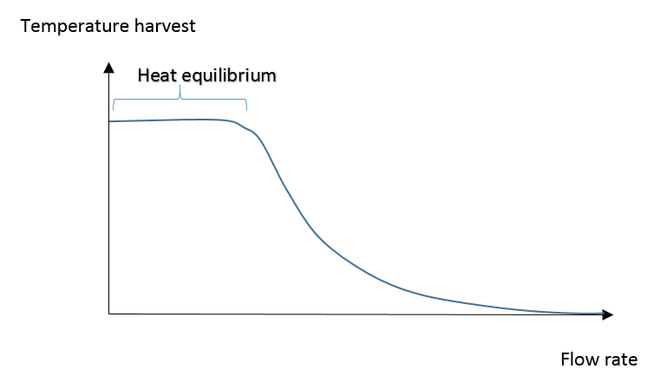

Figure 14: Hypothesis of flow rate - temperature recovery correlation

*The graph was derived from the experimental result that the three investigated flow rates were not in a linear relation to the temperature recovery and the theoretical assumption that a heat equilibrium exist.*

The absolute temperature of the inlet water was logged with around 40 °C in the data files. This result has to be explained regarding the additional statement that the surrounding temperature of the lab environment was around 20 °C and the manual measured bucket temperature was around 30 °C. The thermocouples were mounted inside a metal pipe structure only about 1 cm away from the cooling coil. This metal pipe structure heated the water up before it could reach the sensor. On the one hand this means the actual temperature recovery is in reality greater than the experimental data suggested. On the other hand the temperature of the solar cell was with 90 °C probably above a typical value in a warm climate region. Due to the greater temperature gradient in the experiment, more temperature could be harvested in the experiment than under real outdoor conditions. It is assumed that both effects equalise each other.

The curves in Diagram 8 and Diagram 9 have a similar progression, which highlights again the strong entanglement of solar cell temperature and temperature recovery. Even towards the end, both diagrams show really similar spatial arrangements with the 36 ml/min and 26 ml/min line closer together than the 26 ml/min and 16 ml/min line.

In the appendix (11.1. Equation to determine the rate of heat flow to the distillation unit) is the derivation of the (Formula 11), which is copied and pasted below as (Formula 7). It enables the determination of the rate of heat flow to the distillation unit at the steady state point.

.

$$Q=4174472\frac{J}{°C m^{3}}∙V∙{∆T}_{outlet-inlet}$$

$$Q:Rate of heat flow (W) V: volumetric flow rate \left(\frac{m^{3}}{s}\right)$$

$${∆T}_{outlet-inlet} : Water temperature difference between outlet and inlet (°C)$$

Formula 7: Rate of heat flow to distillation unit 3

|  |  |  |  |
| --- | --- | --- | --- |
| Flow rate | Flow rate in SI-Units | Temperature recovery  at steady state point | Rate of heat flow  to distillation unit  at steady state point |
| 36 ml/min | 6 · 10-7 m3/s | 3.5 °C | 8.8 W |
| 26 ml/min | 4.33 · 10-7 m3/s | 6 °C | 10.8 W |
| 16 ml/min | 2.67 · 10-7 m3/s | 11 °C | 12.3 W |

Table 8: Temperature output and heat recovery at stead state point

The (Formula 7) was also used to calculate the rate of the heat flow over time for every flow rate as seen below.

Diagram 12: Rate of heat flow to distillation unit over time

*The graph shows how the different flow rates 36 ml/min, 26 ml/min and 16 ml/min influence the rate of heat flow to the distillation unit over time. The solar cell had a very high temperature at the beginning of the experiment, so that the cooling effect of the flow rates can easily be observed.*

Initially the temperature difference between in- and outlet was for all three flow rates the same (Diagram 8). Consequently the 36 ml/min flow rate recovers more heat energy due to its greater flow rate value than the other two ones in the beginning. The (Diagram 12) shows a crossing of all three flow rate lines at nearly the same point. It is a hypothesis at the moment that all flow rate lines always cross at one common point. But should this be true, then it would be worthwhile to find out this crossing point. In the case of only maximising the heat extraction of the proposed batch system (9.2. Conclusions and recommendations). The pump could be operated the first few minutes with the highest flow rate and then switched at this crossing point to the lowest flow rate.

In the appendix (11.2. Theoretical equation between ${∆T}_{outlet-inlet}, Tsolar_$ 𝒄𝒆𝒍𝒍 and volumetric flow rate V) is the derivation of the (Formula 14), which is copied and pasted as (Formula 8) below. As mentioned in the appendix, this formula cannot be used to calculate the exact values, but it is useful to identify relations between the three values.

$${∆T}_{outlet-inlet} \left(V+1.3796∙{10}^{-6}\frac{ m^{3}}{ s}\right)= 2.75921∙{10}^{-6}\frac{ m^{3}}{ s} \left(T_{solar_cell} – 40 °C\right)$$

Formula 8: Theoretical heat transfer between solar cell and cooling unit 3

The formula suggest for a constant flow rate V a linear relation between ${∆T}_{outlet-inlet}$ and $T_{solar_cell}$. Also $T_{solar_cell}$ is in a linear relation with the power output according to (Formula 5). Hence, if both equations are applied together at a constant flow rate V, then ${∆T}_{outlet-inlet}$ is in a negative linear relation to the power output. It is not scope of the research question to investigate this correlation. Therefore the following paragraph will not discuss it in detail but nonetheless the equation includes the most fundamental relation between the two parameters, responsible for the efficiency of the “Sunshine and Shower” technology. The regression analysis of the 36 ml/min flow rate showed a correlation of 0.8 (R2), which is not as significant as the correlation observed at the cooling and heating experiment. But keeping into mind, that the (Formula 8) describes several heat equilibriums equations at ones and there are always heat loses to the surrounding air in reality, it is still a remarkable result. The following diagrams show this correlation.

Diagram 13: Temperature difference and power output correlation 1

*The temperature recovery for the 36 ml/min flow rate is shown against the power output of the solar cell, which was continuous cooled down in the experiment. The theoretical expected linear correlation does not exist anymore due to heat loses to the surrounding air. But it is still slightly indicated.*

Diagram 14: Temperature difference and power output correlation 2

The temperature recovery for the 26 ml/min flow rate is shown against the power output of the solar cell, which was continuous cooled down in the experiment. The theoretical expected linear correlation does not exist anymore due to heat loses to the surrounding air. But it is still slightly indicated.

Diagram 15: Temperature difference and power output correlation 3

The temperature recovery for the 16 ml/min flow rate is shown against the power output of the solar cell, which was continuous cooled down in the experiment. The theoretical expected linear correlation does not exist anymore due to heat loses to the surrounding air. But it is still slightly indicated

### 8.2.3. Limitations of the data

In general, the differences in the power harvest experiment are not very much and small variation can affect the experimental data remarkable. It is therefore recommended to repeat this experiment with a solar panel module to investigate the differences in more detail or choose greater flow rate intervals as well as compare more than three sets of different flow rate data.

# 9. Final statements

## 9.1. Summary of the key findings

The theoretical relation between temperature increase and power output drop could be observed. Also the quantitative analysis at a 20 °C solar cell temperature decrease showed with 6.7 % efficiency improvement a close connection to the theoretical expected value of 8 % (Zondag 2008).

The flow rate experiments suggest the following power and heat recovery values (Table 9) for a typical 1 m2 solar module with rated power of 140 W (Ownergy 2015). The break-even point to operate the pump would be 9 m2. The values are derived under the assumption of a very sunny and warm day. The overall comparison between the power harvest and heat recovery revealed that the steady state point of the heat recovery was achieved faster than the steady state point of the power harvest for all flow rates. All in all the heat recovery is also 22 to 31 times greater than the additional generated power.

|  |  |  |
| --- | --- | --- |
| Flow rate | Additional power harvest | Heat recovery |
| 36 ml/min | 6.1208 W | 132 W |
| 26 ml/min | 5.9668 W | 161 W |
| 16 ml/min | 5.8408 W | 183 W |

Table 9: Summary of the power and heat recovery for different flow rates

The research aim was achieved by providing the key performance values of the “Sunshine and Shower” system (Table 9) and the experimental proof of the mitigation effect of the technology in a warm climate. It was also achieved to provide the basis experimental background to optimise the technology regarding the flow rate.

## 9.2. Conclusions and recommendations

Feasibility  
From my point of view, it has to be tested if the pump can support a closed cooling cycle behind 9 m2 to achieve the break-even point, but even if the pump is appropriate for this application, the cooling effect will not be as good as before. In defence of it, the application area of the pump is actually in the high precision dosage of chemical or biological compounds and is not optimised for unsophisticated energy efficient pumping. As a consequence my recommendation is to set higher priorities on passive cooling systems or high efficiency pumping systems before the scaling up process should be conducted. As long as it is possible to develop such an efficient pumping system, the derived values (Table 9) not only provide the experimental proof of the feasibility but also show its great potential.

Perhaps also a pump with greater flow rate or improvements in the heat transfer should be considered due to the fact that the solar cell is still hot with its remaining 60 °C. Fins are one example for a better heat transfer between the solid part of the solar cell and cooling fluid. They will not only increase the contact surface area between fluid and solid solar cell but also operate as separator so that no tube design is necessary any more (Figure 15).

In general 90 °C solar cell temperature seems to be very high and probably will not be achieved outside the lab. For upcoming experiments it may be reasonable to mount the lamps higher than 12 cm.

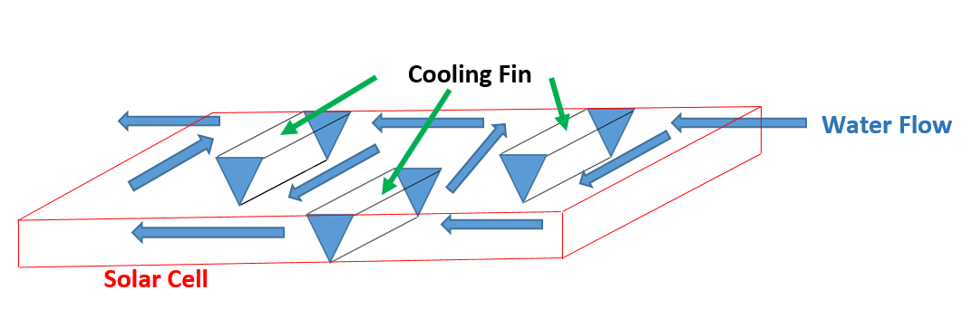

Figure 15: Recommended fin design

*The triangle-shaped cooling fins will increase the heat transfer surface area between the solid solar cell and fluid. Every fin will also serve as separator and force the water to flow in serpentines. This cooling box can then be applied as retrofit option to already existing solar cell installation.*

Optimisation of the Flow Rate

The range of the pump’s flow rate values were nearly covered by the experiment. Taken into account that at a typical 1 m2 solar module with rated power of 140 W (Ownergy 2015), this means only a difference between 0.28 W to operate the cooling unit with highest or lowest possible flow rate. I doubt that the additional energy needed to operate the pump at a very high flow rate can be balanced out by this 0.28 W additional power. Although it is possible that a range exists between 0 - 16 ml/min or 36 - ∞ ml/min in which the flow rate has a more significant effect on the power output and therefore has to be considered. But based on the derived values, I would suggest that it is not worthwhile to operate the pump at 26 ml/min or 36 ml/min flow rate due to the immense heat recovery drop of 22 W or 51 W, respectively.

I would also recommend to investigate if the 1/3 part of the solar cell, which is not cooled down at the moment, has a significant greater effect on the overall power output than the experimental data suggested. Experiments about partial-shading showed, that due to the cells aligned in series, the weakest cell will determine the power output (4. Literature review).

It is also reasonable to test a batch system in the future as well, because it could have a few advantages over a constant flow design. The pump and heat exchanger will be switched off until the water under the solar cell reaches a specific point. Then the pump will be switched on and will only pump as long as the water is replaced in the cooling unit. The batch system should operate the pump regarding the best heat recovery from Diagram 12, which means to pump at the highest flow rate and switch to the lowest one when the crossing point in Diagram 12 is reached. Although the pump will be operated at a higher flow rate compared to the constant flow design, the pump is most of the time switched off together with the other appliances (e.g. heat exchanger), which could save energy in total. This approach also guarantees a more uniformly cool down of the solar cell, which benefits the potential solar cell alignment in series (4. Literature review). Perhaps the instance of having cooled water behind the solar cell instead of nothing, would cool down the solar cell in a similar way than the investigated constant flow design, especially because the solar cell did not react very strong on the changed flow rate settings. The batch system will also transport the generated heat in batches and less heat can be lost during transmission to the distillation unit.

## 9.3. Future work and expansion of the project

Before long term field trials can be started, the “Sunshine and Shower” technology will need to be optimised regarding different extraction modes and the point of switching between these modes. Three different modes are suggested in an optimal case.

1. Night-Mode: Whole cooling unit is switched off (no electricity use of the pump)
2. Morning / Evening-Mode: Pump is switched on, but no heat extraction (heat yield is too low; possible bypass integration to avoid heat extraction of the heat exchanger)
3. Daytime-Mode: Pump is switched on and heat is extracted.

Beside these technical improvement steps, also new rising theoretical questions can be investigated in the future such as how this energy efficiency improvement device will interact with the whole grid activity. Depending on the penetration of PV cells in a micro grid, it is often necessary to disconnect them during peak generation to avoid any instability in the grid. Energy efficiency improvement devices have in common that they increase the power output during peak generation, when it is more likely that it is wasted or generates load problems to the grid operator. The “Sunshine and Shower” has also the characteristic to increase the generation during peak generation.

# 10. Literature

Abdul Hamid, S. et al., 2014. An overview of photovoltaic thermal combination (PV/T combi) technology. *Renewable and Sustainable Energy Reviews*, 38, pp.212–222.

Bakker, M. et al., 2005. Performance and costs of a roof-sized PV/thermal array combined with a ground coupled heat pump. *Solar Energy*, 78(2), pp.331–339.

Best-Microcontroller-Projects, 2015. How RS232 works. Available at: http://www.best-microcontroller-projects.com/how-rs232-works.html [Accessed September 19, 2015].

Current Sensor DataSheet, 2015. ACS712. Available at: https://www.sparkfun.com/products/8883 [Accessed September 19, 2015].

Dolara, A. et al., 2013. Experimental investigation of partial shading scenarios on PV (photovoltaic) modules. *Energy*, 55, pp.466–475.

Eltawil, M.A. & Omara, Z.M., 2014. Enhancing the solar still performance using solar photovoltaic, flat plate collector and hot air. *Desalination*, 349, pp.1–9.

Engineering ToolBox, 2014. Water - Density and Specific Weight. Available at: http://www.engineeringtoolbox.com/water-density-specific-weight-d_595.html [Accessed September 19, 2015].

Engineering ToolBox, 2015. Water - Thermal Properties. Available at: http://www.engineeringtoolbox.com/water-thermal-properties-d_162.html [Accessed September 19, 2015].

EU Climate Action Program, 2015. EU Climate Targets for 2020. Available at: http://ec.europa.eu/clima/citizens/eu/index_en.htm [Accessed September 19, 2015].

Flendrig, L.M. et al., 2009. Low cost thermoformed solar still water purifier for D&E countries. *Physics and Chemistry of the Earth, Parts A/B/C*, 34(1-2), pp.50–54.

Herrando, M., Markides, C.N. & Hellgardt, K., 2014. A UK-based assessment of hybrid PV and solar-thermal systems for domestic heating and power: System performance. *Applied Energy*, 122, pp.288–309.

Honsberg, C. & Bowden, S., 2015. Effect of parasitic Resistances. Available at: http://www.pveducation.org/pvcdrom/solar-cell-operation/effect-of-parasitic-resistances [Accessed September 19, 2015].

Honsberg, C. & Stuart, B., 2015. Effect of Temperature. Available at: http://www.pveducation.org/pvcdrom/solar-cell-operation/effect-of-temperature [Accessed September 19, 2015].

Ibrahim, A., Othman, M.Y. & Ruslan, M.H., 2009. Performance of Photovoltaic Thermal Collector (PVT) With Different Absorbers Design. *WSEAS Transactions On Environment And Development*, 5(3), pp.321–330.

Ismatic, 2015. Reglo-Cpf pump. Available at: http://www.ismatec.com/int_e/pumps/p_reglo_cpf_analog/reglo_cpf_analog_drive.htm [Accessed September 19, 2015].

Jasrotia, S., Kansal, A. & Kishore, V.V.N., 2012. Application of solar energy for water supply and sanitation in Arsenic affected rural areas: a study for Kaudikasa village, India. *Journal of Cleaner Production*, 37, pp.389–393.

Karimi Estahbanati, M.R. et al., 2014. Experimental investigation of a multi-effect active solar still: The effect of the number of stages. *Applied Energy*, 137, pp.46–55.

Keithley Instruments Inc, 2015. Key Solar Cell Parameters and Measurement Techniques. Available at: http://www.keithley.com/solar_cell [Accessed September 19, 2015].

Keyword Suggestion, 2015. Binary ASCII. Available at: http://www.suggestkeyword.com/YmluYXJ5IGFzY2lp/ [Accessed September 19, 2015].

Kulandaivel, K.M. & Kapruppiah, S., 2014. Single Basin Double Slope Solar Still - Year Round Performance Prediction for local climatic Condtions at southern India. *Thermal Science. 2014*, 18(2), pp.429–438.

MAX232 - DataSheet, 2015. MAX232. Available at: http://www.ti.com/lit/ds/symlink/max232.pdf [Accessed September 19, 2015].

Mittelman, G. et al., 2009. Water desalination with concentrating photovoltaic/thermal (CPVT) systems. *Solar Energy*, 83(8), pp.1322–1334.

Muthu Manokar, A., Kalidasa Murugavel, K. & Esakkimuthu, G., 2014. Different parameters affecting the rate of evaporation and condensation on passive solar still – A review. *Renewable and Sustainable Energy Reviews*, 38, pp.309–322.

Ownergy, 2015. Solar Photovoltaics. Available at: http://www.ownergy.co.uk/roof_solar/about/ [Accessed September 19, 2015].

RS232 To TTL Converter - DataSheet, 2015. RS232 To TTL Converter. Available at: http://www.alibaba.com/product-detail/2014-new-hot-sale2014-newest-30Pcs_1807706408.html [Accessed September 19, 2015].

Singh, P. & Ravindra, N.M., 2012. Temperature dependence of solar cell performance—an analysis. *Solar Energy Materials and Solar Cells*, 101, pp.36–45.

SolarTaos, 2015. Solar Electric Panels. Available at: http://www.outbacksolarproducts.com/panels.html [Accessed September 19, 2015].

Šuklje, T., Medved, S. & Arkar, C., 2013. An Experimental Study on a Microclimatic Layer of a Bionic Façade Inspired by Vertical Greenery. *Journal of Bionic Engineering*, 10(2), pp.177–185.

The National Business, 2014. Abu Dhabi entrepreneur tackles world’s devastating water crisis. Available at: http://www.thenational.ae/business/the-life/abu-dhabi-entrepreneur-tackles-worlds-devastating-water-crisis#page2 [Accessed September 19, 2015].

Thermocouple Amplifier DataSheet, 2015. Thermocouple Amplifier. Available at: https://www.adafruit.com/products/1778 [Accessed September 19, 2015].

Tobnaghi, D.M., Madatov, R. & Farhadi, P., 2013. Investigation of light intensity and temperature dependency of solar cells electric parameters. Available at: http://ena.lp.edu.ua:8080/bitstream/ntb/26855/1/031-090-093.pdf [Accessed September 19, 2015].

USB-Gear, 2015. USB to RS-232 Adapter. Available at: https://www.usbgear.com/CHEAP-SERIAL.html [Accessed September 19, 2015].

William, J. et al., 2015. Desolenator. Available at: http://desolenator.com/ [Accessed September 19, 2015].

Zondag, H., 2008. Flat-plate PV-Thermal collectors and systems: A review. *Renewable and Sustainable Energy Reviews*, 12(4), pp.891–959.

# 11. Appendix

## 11.1. Equation to determine the rate of heat flow to the distillation unit

The volumetric flow rates are converted in the following (Table 10) to SI-units (International System of Units).

|  |  |  |
| --- | --- | --- |
| ml/min | l/s | m3/s |
| 36 | 6 * 10-4 | 6 * 10-7 |
| 26 | 4.33 * 10-4 | 4.33 * 10-7 |
| 16 | 2.67 * 10-4 | 2.67 * 10-7 |

Table 10: Volumetric flow rate conversion table

The formula (11) from (Herrando et al. 2014) describes the rate of heat flow as follows.

$$Q=m∙c_{p}∙{∆T}_{outlet-inlet}$$

$$Q:Rate of heat flow (W) m :mass flow rate \left(\frac{kg}{s}\right)$$

$${ c}_{p}:specific heat capacity of fluid \left(\frac{J}{kg ∙ °C}\right)$$

${∆T}_{outlet-inlet} : Water temperature difference between outlet and inlet (°C)$

Formula 9: Rate of heat flow to distillation unit 1

The mass flow rate was defined as product between the density of the fluid and the volumetric flow rate.

$$Q=ρ∙V∙c_{p}∙{∆T}_{outlet-inlet}$$

$$ρ:density of fluid \left( \frac{kg}{m^{3}}\right) V: volumetric flow rate \left(\frac{m^{3}}{s}\right)$$

$${ Q:Rate of heat flow (W) c}_{p}:specific heat capacity of fluid \left(\frac{J}{kg ∙ °C}\right)$$

$${∆T}_{outlet-inlet} : Water temperature difference between outlet and inlet (°C)$$

Formula 10: Rate of heat flow to distillation unit 2

The specific heat capacity of water is $4182\frac{J}{kg °C}$ at 20 °C (Engineering ToolBox 2015) and the density is $998.2 \frac{kg}{m^{3}}$ at 20 °C (Engineering ToolBox 2014).

$$Q=4174472\frac{J}{°C m^{3}}∙V∙{∆T}_{outlet-inlet}$$

$$Q:Rate of heat flow (W) V: volumetric flow rate \left(\frac{m^{3}}{s}\right)$$

$${∆T}_{outlet-inlet} : Water temperature difference between outlet and inlet (°C)$$

Formula 11: Rate of heat flow to distillation unit 3

## 11.2. Theoretical equation between ${∆T}_{outlet-inlet}, T_{solar_cell}$ and volumetric flow rate V

The rate of heat flow can also be described in a different relation according to formula (10) in (Herrando et al. 2014).

$$Q= h_{w} (T_{ab} – T_{bw})$$

$$Q:Rate of heat flow \left(W\right) T_{ab} :Temperature absorber plate (°C)$$

$$T_{bw }:bulk temperature of the fluid in the collector (°C)$$

$$h_{w}: convective heat transfer coefficient of the fluid flow in the pipes \left(\frac{W}{m^{2} °C}\right)$$

Formula 12: Theoretical heat transfer between solar cell and cooling unit 1

The absorber plate in the experiment was attached to the solar cell and due to the great heat conductivity of metal it is assumed that the absorber plate temperature is similar to the solar cell temperature.

$$T_{ab}=T_{solar_cell}$$

hw was given for water as 259 W/(m2 °C) in Table B2 in (Herrando et al. 2014) and the surface area of the solar cell in the experiment was 306 x 218 mm2 = 6.6708 · 10-2 m2 (Figure 6). Because 1/3 of the solar cell was not equipped with the cooling coil, it is assumed that the surface area is only 2/3 · 6.6708 · 10-2 m2 = 4.4472 · 10-2 m2

hw is around 259 · 4.4472 · 10-2 W/°C = 11.518248 W/°C in the experiment.

The bulk temperature of fluid in the collector can be assumed to be the average temperature of the water in the pipe. The absolute temperature of the inlet water was around 40 °C (8.2.2.3. Temperature recovery results).

$$T_{bw}={(T}_{outlet}-T_{inlet})/2= 40 °C+{∆T}_{outlet-inlet}/2$$

The following equation was derived through inserting all the single components above into the equation (Formula 12).

$$Q= 11.518248 W/°C (T_{solar_cell} – 40 °C-{∆T}_{outlet-inlet}/2)$$

Formula 13: Theoretical heat transfer between solar cell and cooling unit 2

Unfortunately after applying the collected values for $T_{solar_cell}$ and ${∆T}_{outlet-inlet}$ from the experiment, the model cannot be brought into harmony with the derived Q values from (Formula 11).

|  |  |  |  |  |
| --- | --- | --- | --- | --- |
| V | $$T_{solar_cell}$$ | $${∆T}_{outlet-inlet}$$ | Q from  (Formula 13) | Q from  (  Table 8: ) |
| 36 ml/min | 64 | 3.5 °C | 256 W | 8.8 W |
| 26 ml/min | 66 | 6 °C | 265 W | 10.8 W |
| 16 ml/min | 69 | 11 °C | 271 W | 12.3 W |

Table 11: Comparison of the two models

The red values are definitive too high. The reason could be in the assumption that $T_{ab}=T_{solar_cell}$. It is quite likely that the absorber temperature is significant lower than the solar cell temperature and the relation is rather $T_{ab}={k* T}_{solar_cell}$. Also the estimation of the bulk water temperature was quite imprecise with the average temperature in the water pipe. It is also not totally sure, if the hw value can be transferred to this experiment due to the different kind of absorber design they used in the paper (Herrando et al. 2014). Although the coefficients are not correct, I will go on with the transformation of the formula, because it will reveal a significant fundamental relation between the values.

Connecting (Formula 11) and (Formula 14) gives the following equation.

$$4174472\frac{J}{°C m^{3}}∙V∙{∆T}_{outlet-inlet}= 11.518248\frac{J}{s °C} \left(T_{solar_cell} – 40 °C-\frac{{∆T}_{outlet-inlet}}{2}\right)$$

$$V∙{∆T}_{outlet-inlet}+ 2.75921∙{10}^{-6}\frac{ m^{3}}{ s}\frac{{∆T}_{outlet-inlet}}{2}= 2.75921∙{10}^{-6}\frac{ m^{3}}{ s} \left(T_{solar_cell} – 40 °C\right)$$

$${∆T}_{outlet-inlet} \left(V+1.3796∙{10}^{-6}\frac{ m^{3}}{ s}\right)= 2.75921∙{10}^{-6}\frac{ m^{3}}{ s} \left(T_{solar_cell} – 40 °C\right)$$

$$V: volumetric flow rate \left(\frac{m^{3}}{s}\right) T_{solar_cell}=solar cell temperature (°C)$$

$${∆T}_{outlet-inlet} : Water temperature difference between outlet and inlet (°C)$$

Formula 14: Theoretical heat transfer between solar cell and cooling unit 3

## 11.3. Regression analysis output files

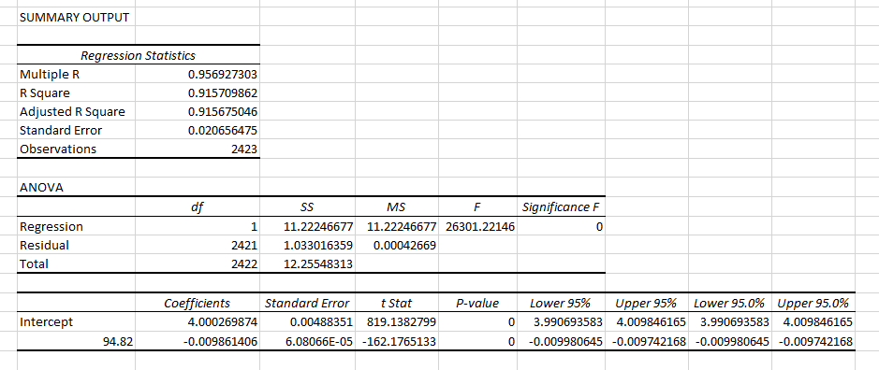

Table 12: Cooling experiment - top temperature sensor

*Detailed regression analysis between the top temperature measurement of the solar cell and the power output. The solar cell was continuous cooled down in the experiment.*

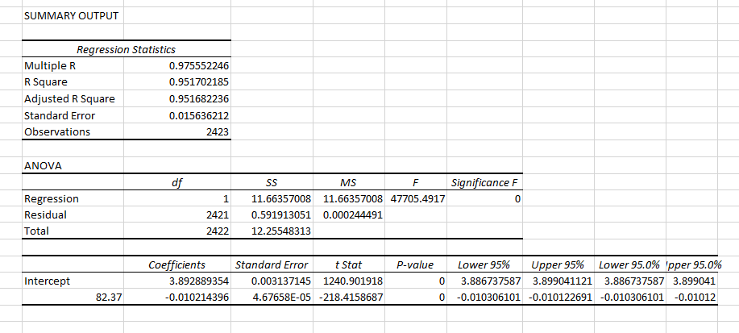

Table 13: Cooling experiment - bottom temperature sensor

*Detailed regression analysis between the bottom temperature measurement of the solar cell and the power output. The solar cell was continuous cooled down in the experiment.*

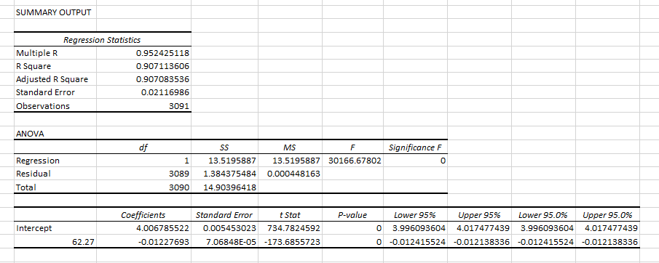

Table 14: Heating experiment - top temperature sensor

*Detailed regression analysis between the top temperature measurement of the solar cell and the power output. The solar cell was continuous warmed up in the experiment.*

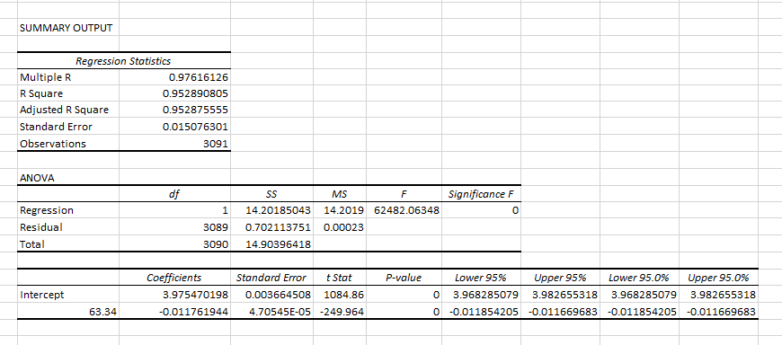

Table 15: Heating experiment – bottom temperature sensor

*Detailed regression analysis between the bottom temperature measurement of the solar cell and the power output. The solar cell was continuous warmed up in the experiment.*

## 11.4. Arduino wiring up manual

### 11.4.1. Serial communication with the REGLO-CPF digital pump

Definition Serial communication:

The data is transmitted bit by bit at a serial communication port. In contrast to parallel communication which sends several bits together, the serial communication is characterised by sending only one bit of data at a time.

Overview of the RS232 communication

The pump has a RS232 input and output port depicted in (Figure 16). Electrical signals are sent by changing the voltage level between a positive and negative value. Commonly used values are +/- 5 V, +/- 10 V, +/- 12 V or +/- 15 V. The logical bit “0” is represented by a positive voltage level and the logical bit “1” is represented by a negative voltage level.

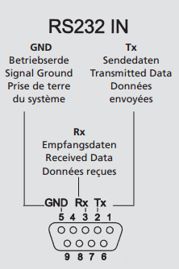

Figure 16: RS232 input

The format of the RS232 signal can be seen in (Figure 17) as 1 start bit, 8 data bits, 1 parity bit (optional) and 1 stop bit. The start bit is always the logical bit “0” and the stop bit is always the logical bit “1”. The 8 data bits in the middle store an ASCII code character, whereas the least significant bit (LSB) is the first bit and the most significant bit (MSB) is the last bit.

As an example the (Figure 18) and (Figure 17) show the transmission format of the letter ‘J’.

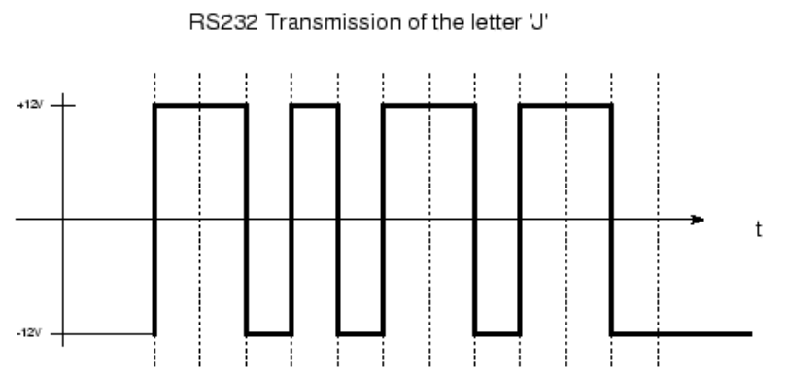

Time

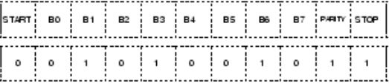

Figure 17: RS232 signal

*The figure shows the voltage level change during the RS232 transmission of the letter `J´.*

*Source: (Best-Microcontroller-Projects 2015)*

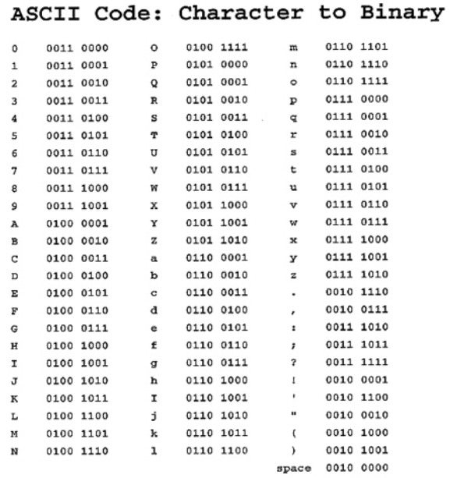

Figure 18: ASCII code

*Source:* (Keyword Suggestion 2015)

The parity bit is optional and can be used to identify errors during the transmission. It indicates whether the transmitted data has an even or odd number of the logical bit “1”. Not all transmission errors can be identified by the parity bit. For example the error can’t be identify in line 2 and 3 of the following example.

Original transmitted data received data with errors

|  |  |  |  |  |
| --- | --- | --- | --- | --- |
| 8 data bits | Parity bit |  | 8 data bits | Parity bit |
| 11111111 | 0 | transmission | 10111111 | 0 (error can be identify) |
| 01010111 | 1 |  | 01100111 | 1 (error can’t be identify) |
| 10000100 | 0 |  | 10101100 | 0 (error can’t be identify) |
| 11100000 | 1 |  | 11100100 | 1(error can be identify) |
| 01010000 | 0 |  | 00011001 | 0 (error can be identify) |

Figure 19: Parity bit error control

*Example of different transmission errors and the ability of the parity bit to identify the error.*

The receiving and sending device have to communicate with the same BAUD RATE, which is a measure for the number of bits sent per second. Therefore a BAUD RATE of 9600 sends 9600 bits of data per second. In your case the BAUD RATE was set to 9600 in the Serial Monitor as well as in the programming code to enable the serial communication between both devices (Figure 20). A Serial Monitor is already included in the Arduino IDE (Integrated Development Environment) and can be used to display receiving serial data on the computer screen.

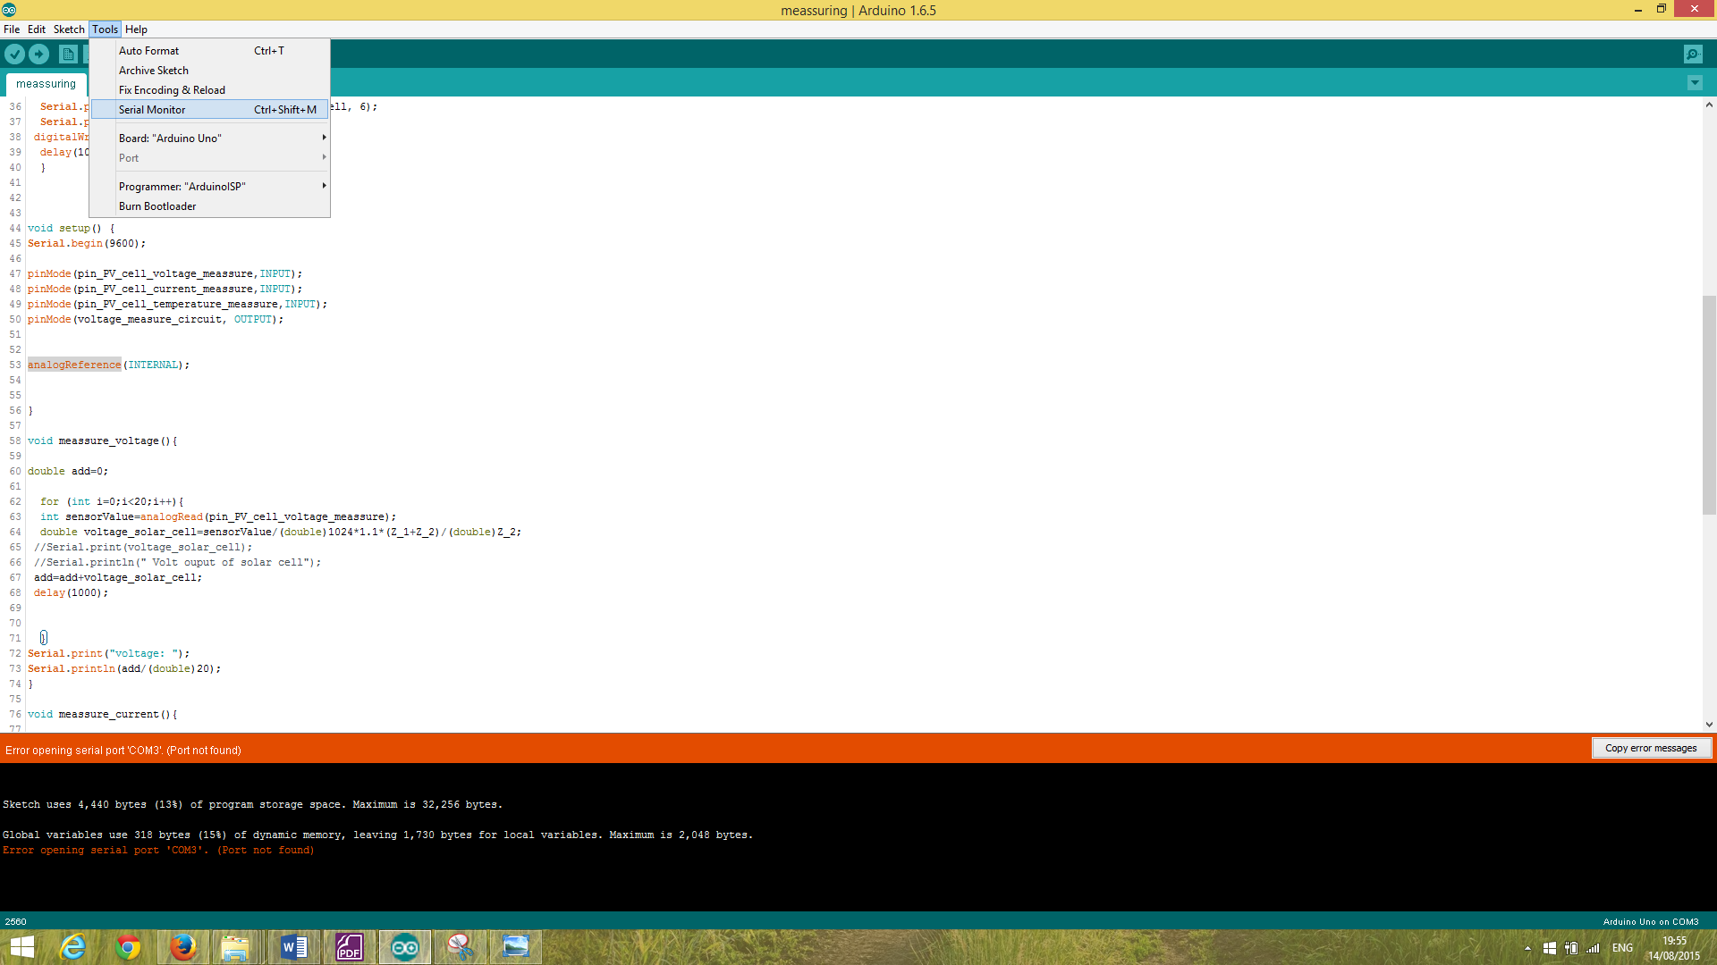 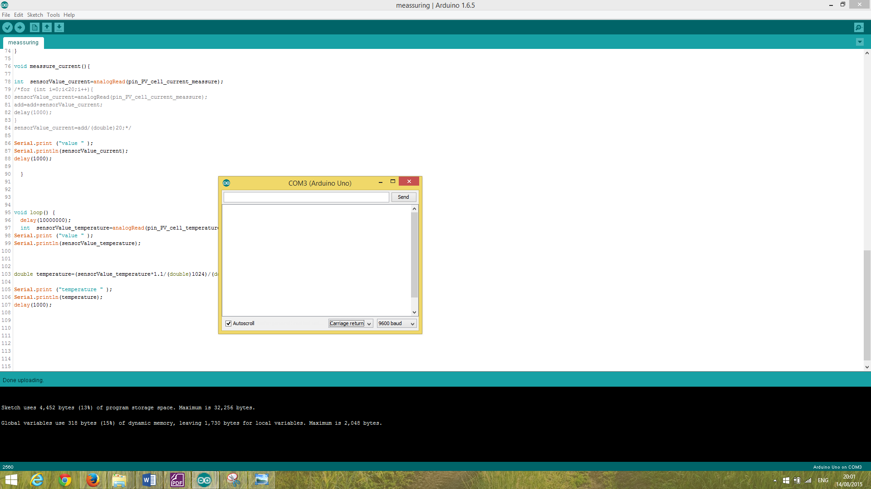

Figure 20: Selection of the BAUD RATE in the serial monitor

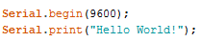 Same BAUD RATE

Figure 21: Setting of the BAUD RATE in the programming code

A RS232 to USB cable (Figure 22) was used in the beginning to connect the pump to the computer. Therefore the in the Arduino IDE included Serial Monitor was available to manual send commands to the pump without using the Arduino board in between. This setup turned out to be the excellent platform for debugging purposes and testing the exact command – response of the pump without programming code.

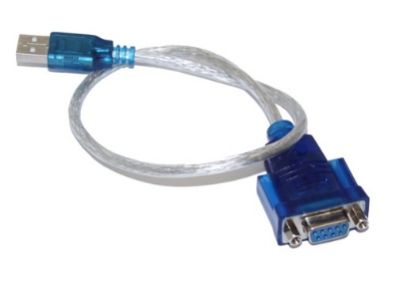

Figure 22: RS232 to USB cable

*Source: (USB-Gear 2015)*

The following example shows the configuration, which is needed to start the pump manual via the Serial Monitor. First of all the pump has to be connected via the RS232 to USB cable with the computer and the correct port has to be selected (Figure 23). Depending on the operating system, the names of the ports can be totally different. In Windows the Serial ports are called COM (communication ports).

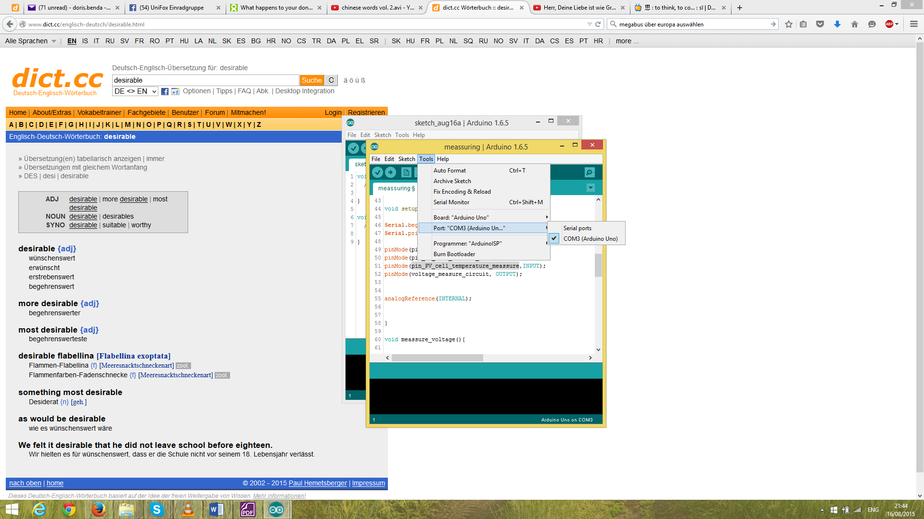

Figure 23: Port selection

*All connected serial ports appear on the right side such as the Arduino Uno board.*

On side 36 of the pump datasheet (Figure 24) is explained that every command starts with the pump address, which is factory-set to 1. But because your pump was used in a cascade experiment before, its address was changed to 2. Therefore every following command will start with 2 instead of 1. Also every command must be completed with the character ASCII 13. This can be achieved, by selecting the “Carriage return” option in the Serial Monitor (Figure 25).



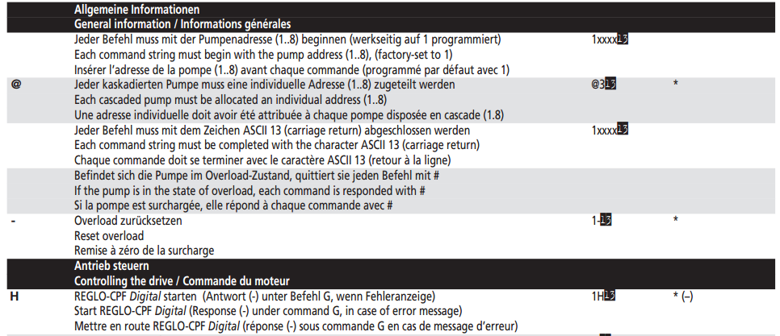





Figure 24: Data sheet

*Extract of the pump data sheet with the basic information about the pump command and response setup.*

*Source: (Ismatic 2015)*

After opening the Serial Monitor (Figure 23), the command can be inserted in the first line and by clicking on the Send-button be transmitted to the pump. The response of the pump will be displayed in the panel underneath and be either the success character * or the fail character – (Figure 25).

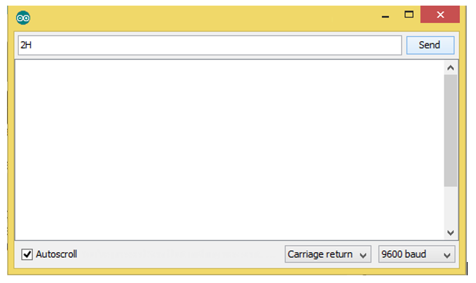

Pump started properly Error during transmission or at the pump

 

Figure 25: Pump response

*Pump response in the Serial Monitor of the Arduino IDE.*

Beside the command character H to start the pump, there are several more command characters documented in the datasheet of the pump. The following list of commands seems to be worthwhile to implement for the upcoming experiment.

Start the pump

Stop the pump

Disable control panel of pump   
(So nobody in the lab can by accident change the settings of the pump.)

Enable control panel of pump

Set flow direction clockwise

Set flow direction anticlockwise

Read current flow rate of the pump

Set the flow rate to a different value

The next step is to atomise the whole command control of the pump with the Arduino board. Due to the maximal input voltage of 5 V to the board, it can’t be directly connected to the pump. Also the Arduino board has a different serial communication format called transistor-transistor logic (TTL). The following (Table 16) depicts differences between both formats. For this purpose a MAX232 chip (MAX232 - DataSheet 2015) mounted on a separated board (RS232 To TTL Converter - DataSheet 2015) was interconnected, which on the one hand reduces the voltage level and on the other hand converts the RS232 logic to TTL logic and vice versa.

|  |  |  |
| --- | --- | --- |
|  | RS232 voltage  pump to MAX232 connection | TTL voltage  MAX232 to Arduino board connection |
| Data transmission (Rx/Tx)  logic 0 | +3 V to +15 V | 0 V |
| Data transmission (Rx/Tx)  logic 1 | -3 V to -15 V | 5V |
| Control signals:  RTS (Request To Send),  CTS (Clear To Send),  DTR (Data Terminal Ready)  and DSR (Data Set Ready)  logic 0 | -3 V to -15 V | 5V |
| Control signals:  RTS, CTS, DTR and DSR logic 1 | +3 V to +15 V | 0 V |

Table 16: RS232 to TTL

A serial port consists in general of a receiving channel (Rx pin) and a transmitting channel (Tx pin). Two devices can communicate with each other when the Rx pin of one device is connected to the Tx pin of the other device and vice versa. The channel crossing in the following experiment was achieved between the pump and the MAX232 chip whereas the connection MAX232 to Arduino board is uncrossed.

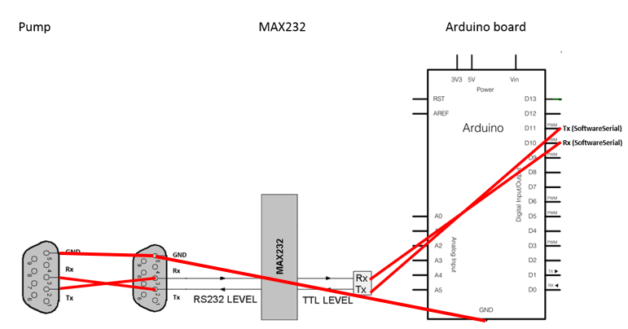

Figure 26: MAX232 connection 1

*The figure depicts the schematic wiring up manual of the serial communication.*

The following pictures (Figure 28) and (Figure 27) show the whole wired up unit with coloured cables.

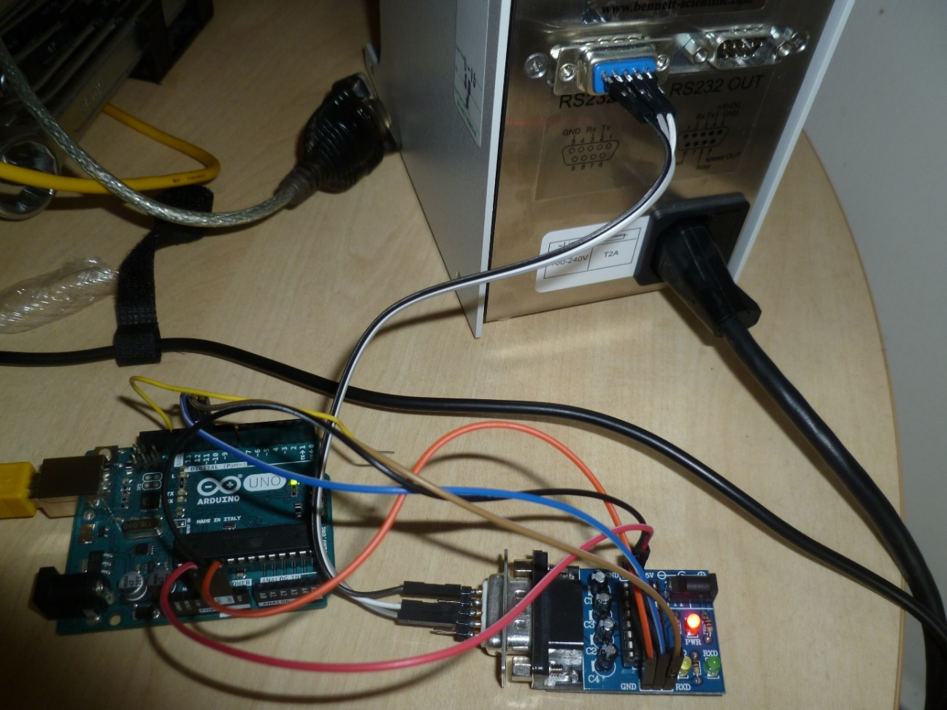

Figure 27: MAX232 connection 2

*The figure depicts the wiring up manual of the serial communication with different coloured cables.*

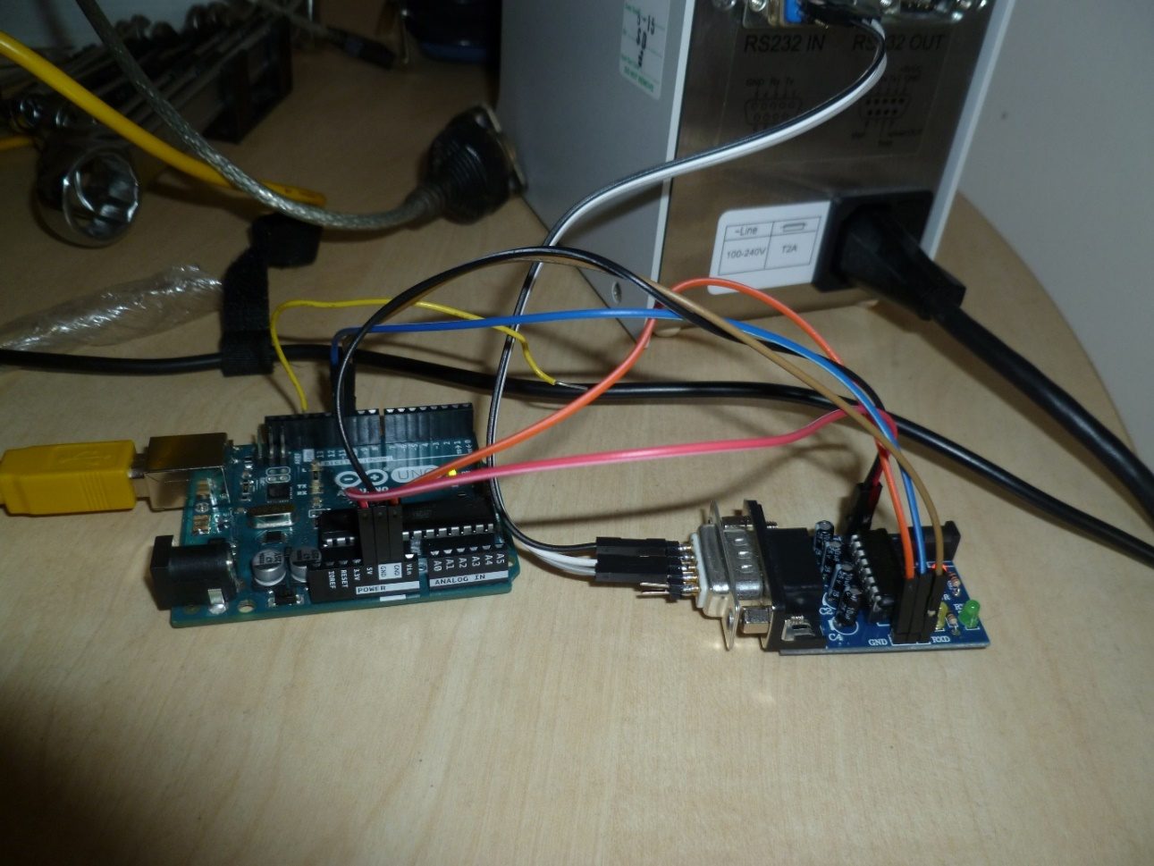

Figure 28: MAX232 connection 3

*The figure depicts the wiring up manual of the serial communication with different coloured cables.*

The Arduino Uno board has only one serial port, which communicates on digital pins 0 (Rx) and 1 (Tx). The same serial port is also active when the board communicates via USB to the computer. Therefore the pins 0 and 1 are unavailable for in- and output data as long as serial communication between the computer and board exists. Due to the fact that no SSD card shield were mounted to the board, it was impossible to store any data on the board even for a short period of time. As a consequence a constant serial communication line between computer and board was unavoidable to store the collected data immediately on the computer. Hence no hardware serial port was available for the MAX232 chip communication. As a solution, the software serial library was included, which simulates the same serial port functionality of the built-in serial port via software so that other pins on the board can act as serial ports as well. A new Software Serial port was declared referred to as mySerial in the programming code. This port on pins 10 (Rx) and 11 (Tx) was connected to the MAX232 chip and operated with the same BAUD RATE of 9600 than the other built-in serial port (Figure 29).

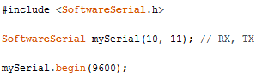

Figure 29: Software serial programming code

The whole developed RegloCPF library can be downloaded from the GitHub website for free.

<https://github.com/DOBEN/reglocpf> (my account)

<https://github.com/brett-lempereur/RegloCPF> (Brett Lempereur’s account)

Its inclusion and declaration are in the following code extract with a list of all available commands.

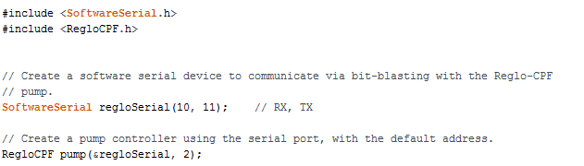

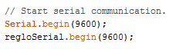

Figure 30: RegloCPF library programming code

|  |  |
| --- | --- |
| Description | Command in Arduino code with “pump” as the RegloCPF controller |
| Start the pump | pump.start(); |
| Stop the pump | pump.stop(); |
| Disable control panel of pump  (So nobody in the lab can by accident change the settings of the pump.) | pump.disable_control_panel(); |
| Enable control panel of pump | pump.enable_control_panel(); |
| Set flow direction clockwise | pump.clockwise(); |
| Set flow direction anticlockwise | pump.counterClockwise(); |
| Read current flow rate of the pump | // Flow rate is given in ml per minute.  // Mantisse will be 4 digits long  // e.g. mantisse = 3600; exponent = -2  // => flow rate 3600*10^-2 ml/min = 36 ml/min  int mantisse = -1;  int exponent = -1;  pump.get_flow_rate( &mantisse, &exponent); |
| Set the flow rate to a different value | // Flow rate is given in ml per minute.  // Is the given flow rate out of range, then the // highest or lowest possible flow rate value will // be set by the pump.  int mantisse = 36;  int exponent = 0;  pump.set_flow_rate( &mantisse, &exponent); |
| Debugging tools | pump.clear_buffer();  pump.read(); |

Table 17: Pump commands

The return values of all functions (except debugging tools) are error check codes, which are encrypted regarding the following table.

|  |  |
| --- | --- |
| 0 | REGLO_OK,  //Command successful. |
| 1 | REGLO_ERROR,  // Command failed. |
| 2 | REGLO_TIMEOUT,  // Response not received in time. |
| 3 | REGLO_OUT_OF_RANGE,  // Parameter is not within safe range. |
| 4 | REGLO_INTERNAL_ERROR, //Internal error in the control interface. |
| 5 | REGLO_BAD_RESPONSE //Unknown response from pump. |

Table 18: Error response of pump

A general problem, which arises when communicating via the serial communication library to the pump, is the fact that a physical component is involved. Hence it response takes sometimes longer than the code is processed by the Arduino.

It has to be find the right balance between waiting for response in the followed programmed while loop and declaring a REGLO_TIMEOUT error to not slow down the whole code too much. This implementation causes in some rare cases the wrong declaration of a REGLO_TIMEOUT error although the command was processed correctly. It is recommended to extend all while loops with REGLO_TIMEOUT errors in the future to secure the leave of the while loop in the case the command of the pump was faster than expected.

The above explained problems are only worthwhile to consider if pump commands are used excessive in the Arduino programming code. In such a case, it is recommended to include delay()-functions between the single commands and stubbornly send a failed command again with simultaneously clearing all data in the buffer, otherwise the serial communication channel will get busy and the whole communication will break down.

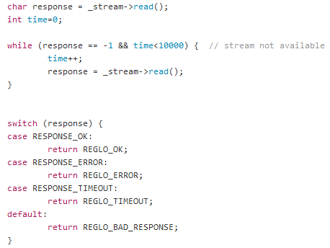

Table 19: Serial communication time out error

### 11.4.2. Voltage measurement

The maximal output voltage of the solar cell is 22 V, which is definitive above the Arduino input pin limit of 5 V. A simple voltage divider distributes the voltage in the circuit according to the (Formula 15) and (Figure 31). The ratio of $\frac{R_{2}}{R_{1}+R_{2}}$ is already set to 0.05, because 22 V should be scaled down to no more than 1.1 V. In chapter 11.4.5. Analog reference value is explained why the input limit of 1.1V is intended rather than 5 V. There are several possible options for the resistor values R1 and R2 to achieve the required ratio. But it should be kept into mind that two opposite requirements limit the choice. Selecting resistor values R1 and R2 as large as possible will result in less wasted current through heat, which is beneficial for the power consumption of the divider and the current measurement. Selecting resistor values R1 and R2 as small as possible will result in more precise voltage measurement as seen in example A. Comparing the precision of the voltage and current measurement, resistor values of 220000 Ω for R1 and 11000 Ω for R2 were selected.

$$V_{Arduino_board}=\frac{R_{2}}{R_{1}+R_{2}}∙V_{solar_cell}= \frac{11000 Ω}{220000 Ω+11000 Ω}∙22 V=1.05 V$$

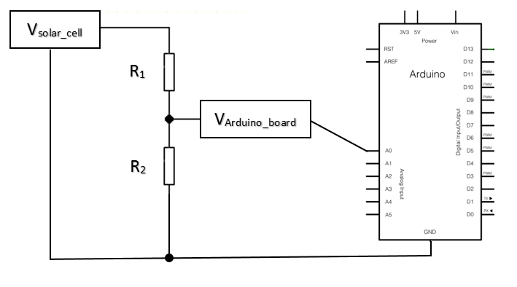Formula 15: Voltage divider

Figure 31: Voltage divider

*Basic schematic diagram of the voltage divider*

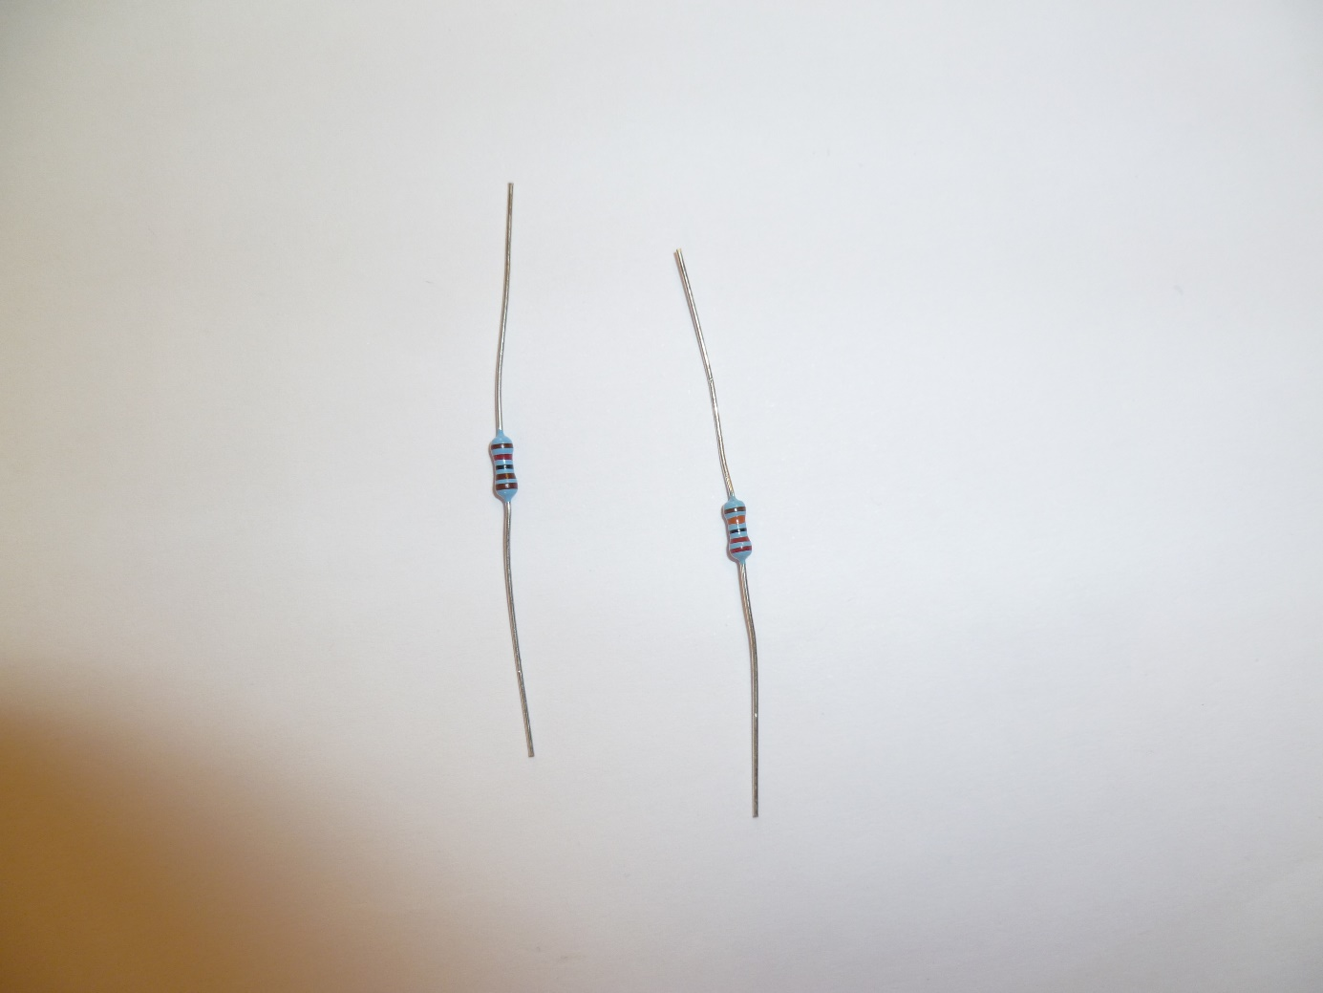

Figure 32: Resistors (left 11000 Ω and right 220000 Ω)

Example A: Why are small resistor values better for the voltage measurement?

Compare these two circuits with a solar cell voltage input of 5 V and no load condition. Both circuits will provide a voltage of 2.5 V to the Arduino board recording to the (Formula 15).

Set-up 1: Small resistor values Set-up 2: Large resistor values

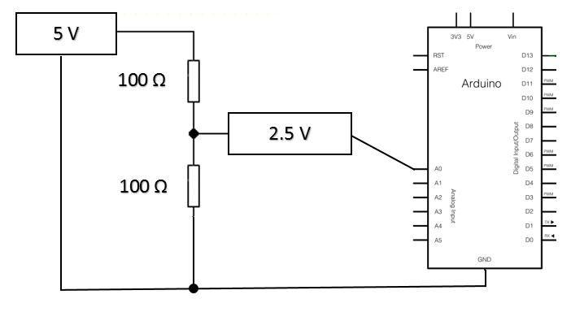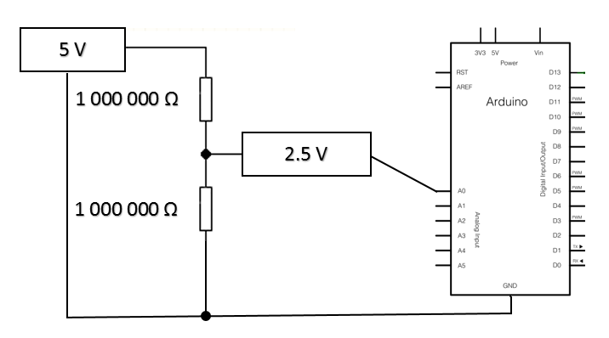

Figure 33: Measurement circuit without load

Every Arduino board has a few resistors internal, which will be in parallel to the resistor R2 during load condition as seen in (Figure 34). Assuming an internal resistance Rin of 1 000 Ω, the combined resistance of R2 and Rin can be determined according to the parallel circuit resistor equation. A combined resistance R2+in of 90.91 Ω and 999 Ω are derived in the following (Formula 16) for set-up 1 and 2, respectively.

Set-up 1:

$$R_{2+in}=\frac{R_{2}∙R_{in}}{R_{2}+R_{in}}= \frac{100 Ω∙1000 Ω}{100 Ω+1000 Ω}=99.91 Ω$$

Set-up 2:

$$R_{2+in}=\frac{R_{2}∙R_{in}}{R_{2}+R_{in}}= \frac{1 000 000 Ω∙1000 Ω}{1 000 000 Ω+1000 Ω}=999 Ω$$

Formula 16: Resistor under load

Hence the voltage provided to the Arduino board is according to formula for:

Set-up 1:

$$V_{Arduino_board}=\frac{R_{2}}{R_{1}+R_{2}}∙V_{solar_cell}= \frac{90.91 Ω}{100 Ω+90.91 Ω}∙5 V=2.38 V$$

Set-up 2:

$$V_{Arduino_board}=\frac{R_{2}}{R_{1}+R_{2}}∙V_{solar_cell}= \frac{999 Ω}{1 000 000 Ω+999Ω}∙5 V=0.00499 V=4.99 mV$$

Formula 17: Voltage measurement under load

As a consequence the measured voltage in set-up 2 is significantly different from the expected 2.5 V. Consequently small resistor values are beneficial for a precise voltage measurement.

Set-up 1: Small resistor values Set-up 2: Large resistor values

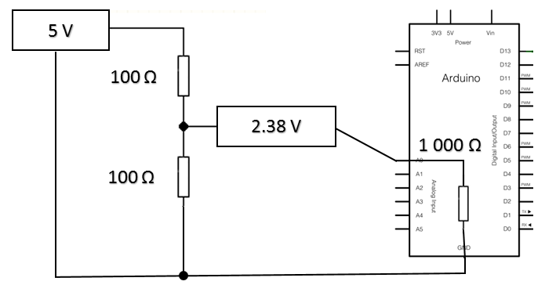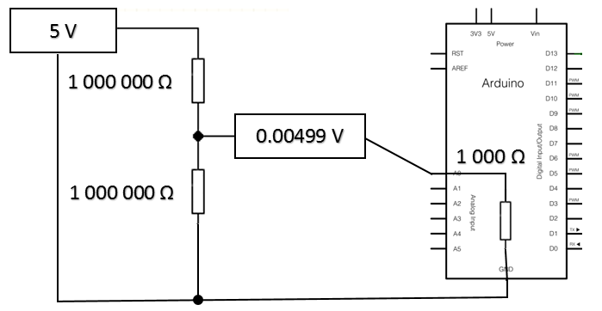

Figure 34: Measurement circuit under load

### 11.4.3. Introducing power resistors as load in the measurement circuit

An electrical circuit has normally a power supply (solar cell) and a load (e.g. lamps, fridge, hair dryer …). In such a circuit, the flowing current has to be measured in series, whereas the voltage is measured in parallel (Figure 35).

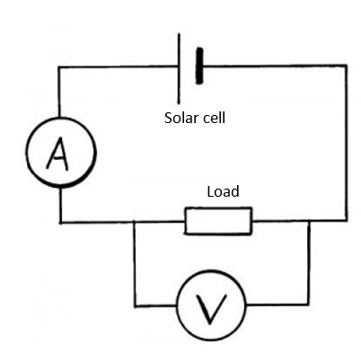

Figure 35: Measurement of current and voltage

The voltage has to be measured in parallel whereas the current has to be measured in series in a basic circuit with load.

The solar cell produces the most power at the maximum power output point. The introduced load should be selected to operate the solar cell at the maximum power output point.



Figure 36: Back of solar cell

*Sticker at the back of the solar cell describes its characteristic values.*

The optimal resistance was 61.19 Ω in the experiment (Formula 18).

$$R_{opt}=\frac{V_{max}}{I_{max}}= \frac{17.5 V}{0.286 A}=61.19 Ω$$

Formula 18: Optimal load

Due to the 5W power output of the solar cell, it is not advised to use standard resistors as seen in (Figure 32). Instead power resistors are recommended, due to the greater surface area, which can disperse the generated heat better. Three 10 W power resistors with 22 Ω resistance were wired up in series to simulate the load in the measurement circuit (Figure 37). The combined resistance of 66 Ω is close enough to the optimal resistance Ropt of 61.19 Ω.

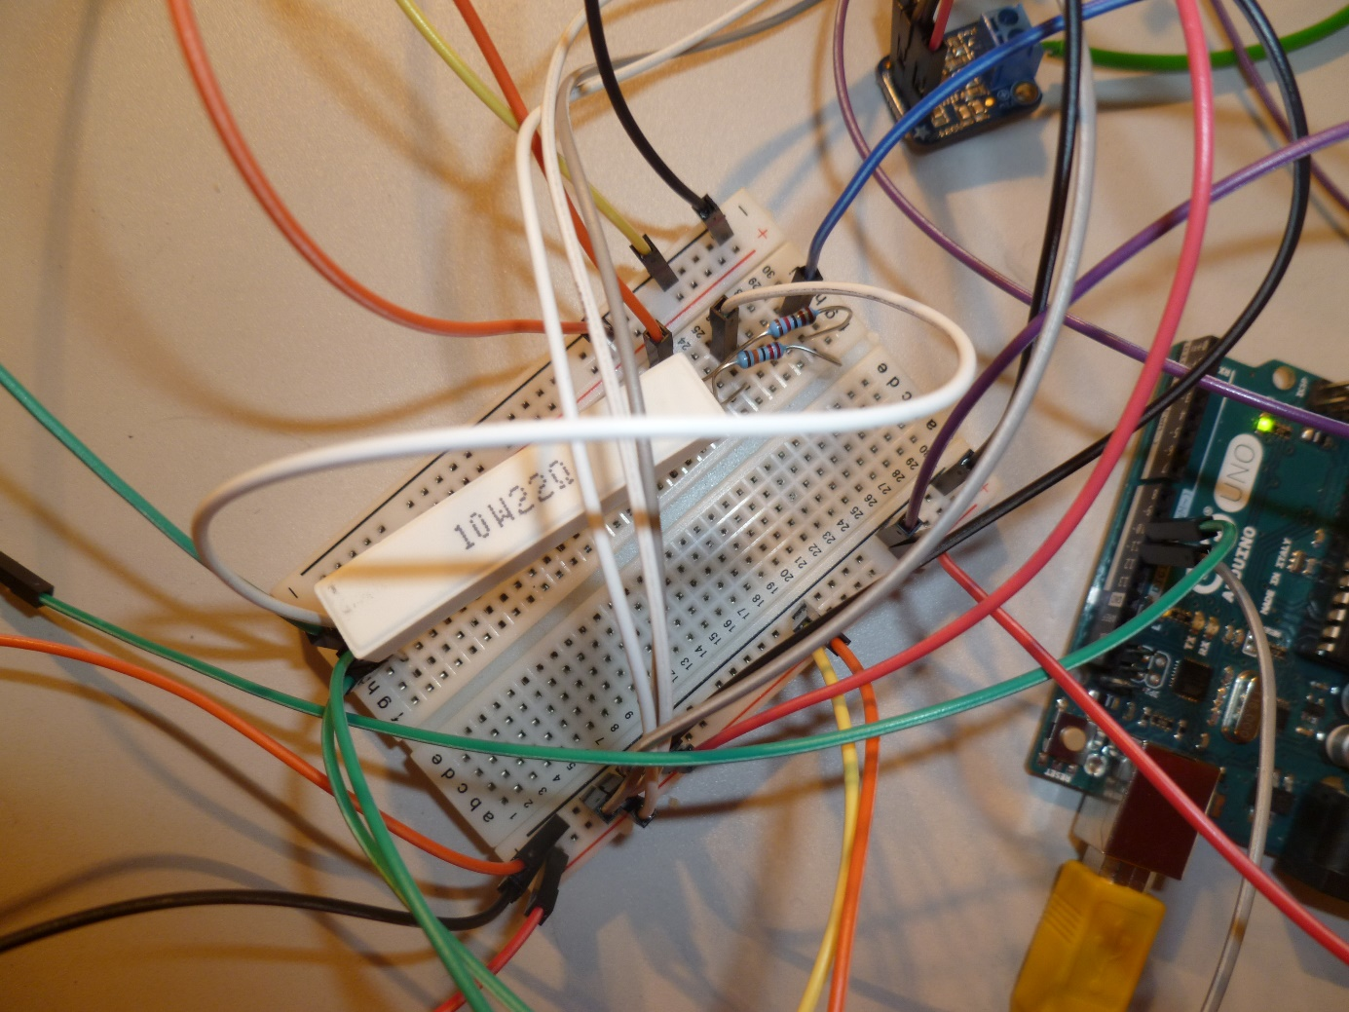

Figure 37: 10 W Power resistor with a resistance of 22 Ω

### 11.4.4. Current measurement

The solar cell can produce a maximal current output of 0.32 A under optimal conditions (no load in measurement circuit and intensive irradiation). But a few simple tests showed that only a range of about 1 A has to be considered for the intended experiment in the lab (Table 20).

|  |  |  |
| --- | --- | --- |
| Measured current | 150 W lamps | Load in measurement circuit |
| 0.7 A | switched off, but surrounding light  from lab environment | 66 Ω |
| 1.7 A | switched on | 66 Ω |

Table 20: Simple test

It is quite a challenge to measure accurate and precise current values in only one Ampere range. Hence the low current sensor ASC712 (05B-T) (Current Sensor DataSheet 2015) was selected. But nonetheless its precision is only 185 mV change per 1 A change, which is not enough considering the following calculation.

An Arduino analogous input pin divides the 0 V - 5 V input range into 1024 unit steps. The ASC712 sensor will provide a voltage level between 0 V - 185 mV for the measured 1 A range, which is equivalent to 38 unit steps (38≈0.185V/5V*1023). The nature of physical experiments has in common that the values given by the Arduino board are randomly jumping around the exact value (low precision). It is therefore not unusual to measure unit steps around 20 - 50 in case of an exact value of 35. Although the average of several values are calculated to increase the precision, it is a bit problematic when the low precision range is as big as the whole possible output range of 38 unit steps. In general, the precision will be increased by increasing the number of collected data points whereas the accuracy will be improved by calibration of the sensors and introducing correction factors in the programming code.

Under this condition, the factory-set functionality of the sensor has to be change completely. With the constraint of setting the analogous reference value to internal in the future (11.4.5. Analog reference value), which means in other words to have an analogous input voltage range of 0 V – 1.1 V on the Arduino board, it was intended to spread the whole expected 0.32 A solar cell range evenly over the 1.1 V input range. By turning the gain and Vref potentiometers (Figure 40), the values are adjustable and the following correlation values were derived (Table 21 and Figure 39).

|  |  |
| --- | --- |
| Input current to sensor | Output voltage of sensor |
| 0 A | 1.11 V |
| 0.105 A | 0.76 V |
| 0.21 A | 0.43 V |
| 0.32 A | 0.1 V |

Table 21: Voltage-current relation of calibrated current sensor

Figure 38: Voltage - current relation of calibrated current sensor

*The internal settings of the current sensor were changed completely to improve its precision. The graphs depict the new output voltage of the sensor compared to the applied current to the sensor.*

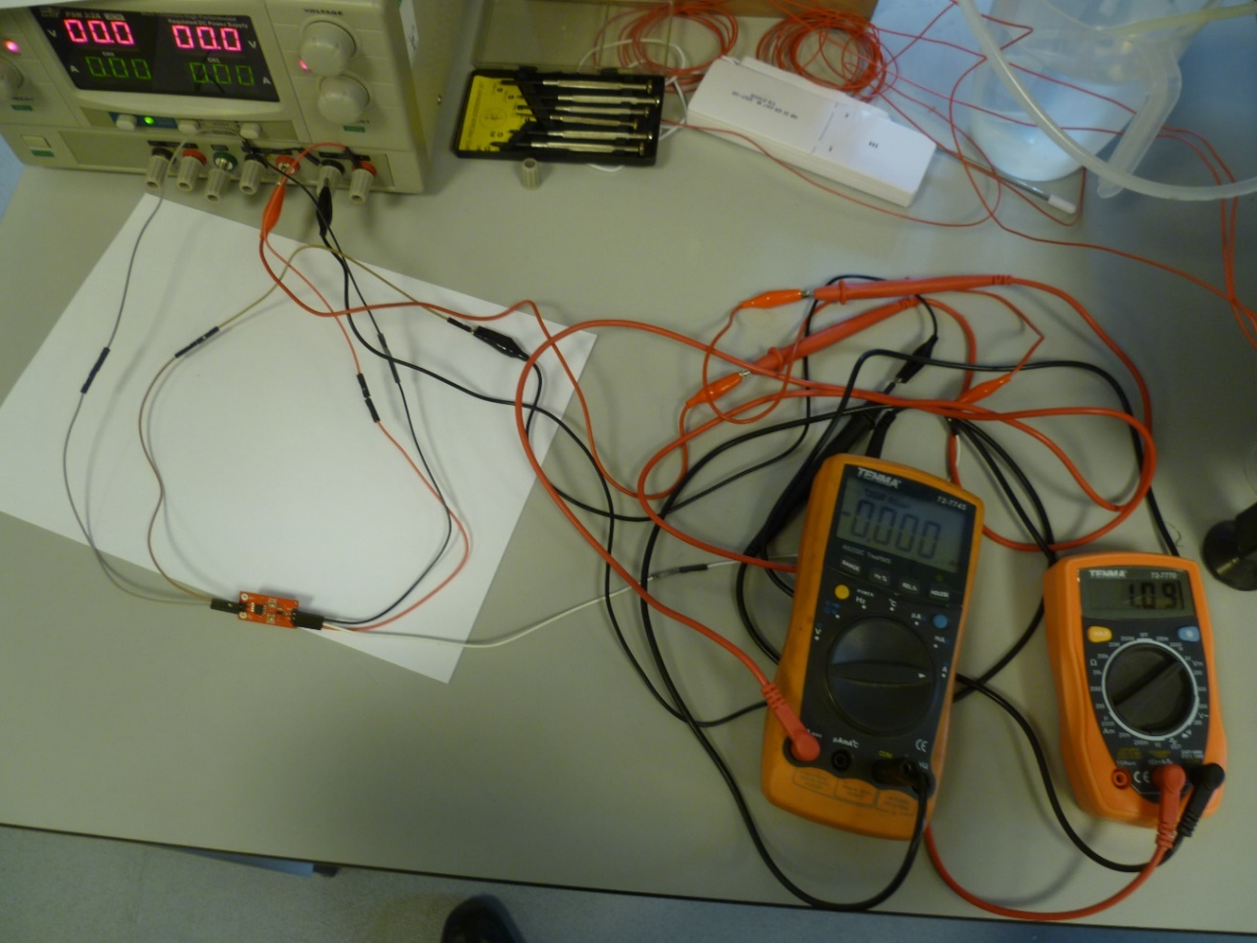

Figure 39: Calibration of the current sensor

*The power supply unit on the left upper corner can provide any current between 0 A – 0.32 A, which will be also measured separately by the left ammeter to verify the value. The right voltmeter displays the output voltage of the sensor. There is 0 A input current provided in the picture, which is transformed to 1.09 V according to the left voltmeter. Now the gain and Vref potentiometers can be turned to adjust the right measurement value until the desired sensor output value is achieved.*

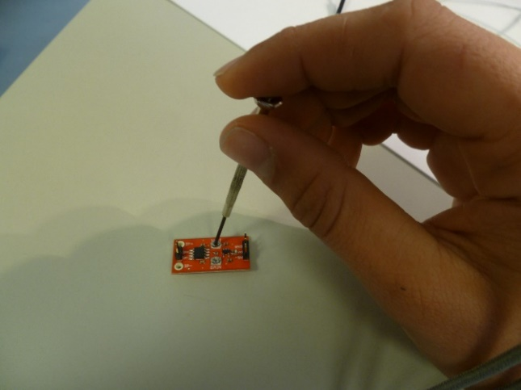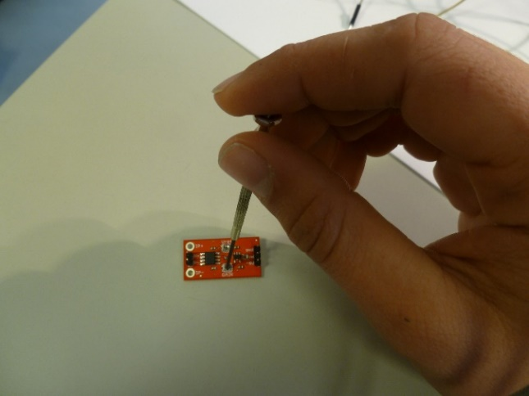

Figure 40: Change of Vref potentiometer on the right and the gain on the left

The linear correlation from the right diagram (Figure 38) was used to derive the voltage-ampere conversion equation.

$$ampere_of_solar_cell= \\ -\frac{0.32}{1.01}∙measured_voltage_at_arduino_pin+\left(0.32+0.1∙\frac{0.32}{1.01}\right)= \\ -0.316832∙measured_voltage_at_arduino_pin+0.3517$$

Formula 19: Ampere - voltage conversion of the current censor

Due to other components in the measurement circuit (e.g. power resistors or voltage divider), an additional correction factor of 0.15 has to be introduced into the formula, which was derived through experimental results. All in all, the following voltage-ampere conversion equation was used in the programming code (Formula 20).



Formula 20: Ampere – voltage conversion of the calibrated current sensor

The precision increased from original 0.0263 A per unit reading (Arduino board) to 0.0014 A per unit reading with an analogous reference value of 5 V or 0.0003 A per unit reading with an analogous reference value of 1.1 V.

### 11.4.5. Analog reference value

The calculations in the previous chapter showed that a lower analogous reference value can remarkable increase the precision of the measurement. Due to this fact, it is intended to use the internal built-in reference of the ATmega328 chip, which is mounted on the Arduino board. The analogous input range will then be scaled down from 0 V – 5 V to 0 V – 1.1 V. The command needed in the programming code can be seen below.



Formula 21: Analogous reference change in the programming code

It should be kept into mind that the reference value will change for all input pins, also for the temperature and voltage sensor pins. Hence every component in this experiment was chosen to support a lower reference value as well. So far the reference value has not been changed to internal, because it is saver to introduce new components or features without this change. In other words, it is more likely to damage the chip on the board with a too high input voltage if the reference value is set to 1.1 V than 5 V. But it is easily possible for future experiments, when the programming code is updated accordingly (5 V has to be replaced by 1.1. V in most formulas).

### 11.4.6. Combined current and voltage measurement circuit

The following (Figure 41) depicts the whole current and voltage measurement circuit.

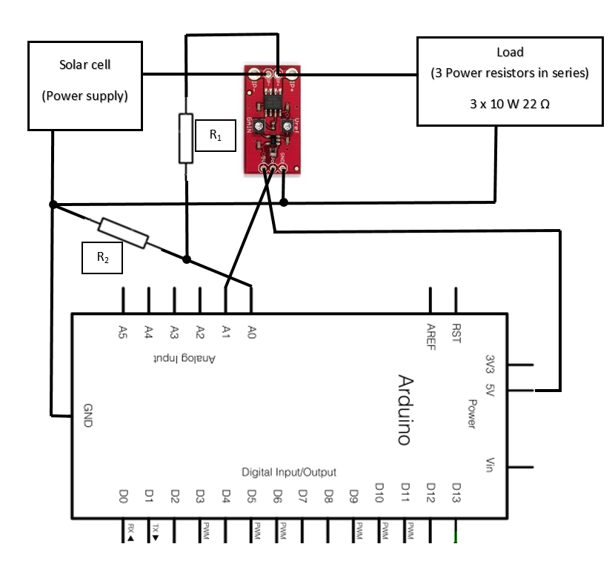

Figure 41: Current - voltage measurement circuit

*It is seen the wiring up manual of the combined current and voltage measurement with the voltage divider in parallel and the current sensor in series.*

### 11.4.7. Thermocouples

A thermocouple is a temperature sensor, which consists of two dissimilar conductors or semiconductors (Figure 42). It produces a voltage output proportional to the temperature difference between the measurement point Tm and reference point Tref. This voltage difference is typically in the range of a few micro volts per °C and needs to be amplified by a separate amplifier board.

Conductor / semiconductor A

Temperature reference point Tref

Voltage difference

Temperature  
measurement point  
Tm

Temperature reference point Tref

Conductor / semiconductor B

Figure 42: Functionality of thermocouples

Four thermocouples were implemented in the final experiment. Two flow temperature thermocouples, one at the water inlet of the cooling coil and one at the outlet of the cooling coil (Figure 45). The temperature of the solar cell was also logged by two thermocouples, one at the top of the solar cell and one at the bottom (Figure 44). All four thermocouples were then connected to an amplifier board of a precision of 5 mV output change per 1 °C change (Thermocouple Amplifier DataSheet 2015). This amplifier board is set up to measure negative temperature until -250 °C as well. Hence originally an offset value of 1.25 was included for the negative temperature range, so that the whole temperature conversion formula was as follows (Formula 22).

$$Measured_temperature=\frac{output_voltage_of_amplifier_board-1.25}{0.0005 V}$$

Formula 22: Thermocouple equation

Due to the fact that an analogous reference value of 1.1 V is intended (11.4.5. Analog reference value). It is necessary to shift down the whole measured temperature range, otherwise the output voltage of the amplifier board will be far above 1.1 V and damage the chip on the board. For this purpose one circuitry on the board is short-circuit to get rid of the negative temperature offset value (Figure 47). Hence the new conversion formula no longer requires an offset value (Formula 23).

$$Measured_temperature=\frac{output_voltage_of_amplifier_board}{0.0005 V}$$

Formula 23: Thermocouple equation calibration

Whenever a thermocouple is connected to the Arduino board, it has to be identified, which amplifier board is connected (Figure 43).

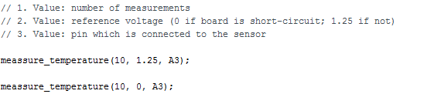

Figure 43: Temperature measurement in the programming code

So far the thermocouples are not calibrated against an accurate thermometer. Hence only the temperature differences of the each thermocouple is considered in the experiments or the worst case scenario is selected by choosing the thermocouple for the inlet temperature measurement, which tends to show a higher value than the outlet thermocouple. Another option would be to conduct all flow temperature experiments twice with opposite flow direction. So that each thermocouple is once connected to the inlet and outlet. The average between the inlet-outlet temperature difference of the two experiments (flow rate is clockwise and anticlockwise) will be free from any accuracy errors. In general, the precision can be improved by increasing the number of collected data points.

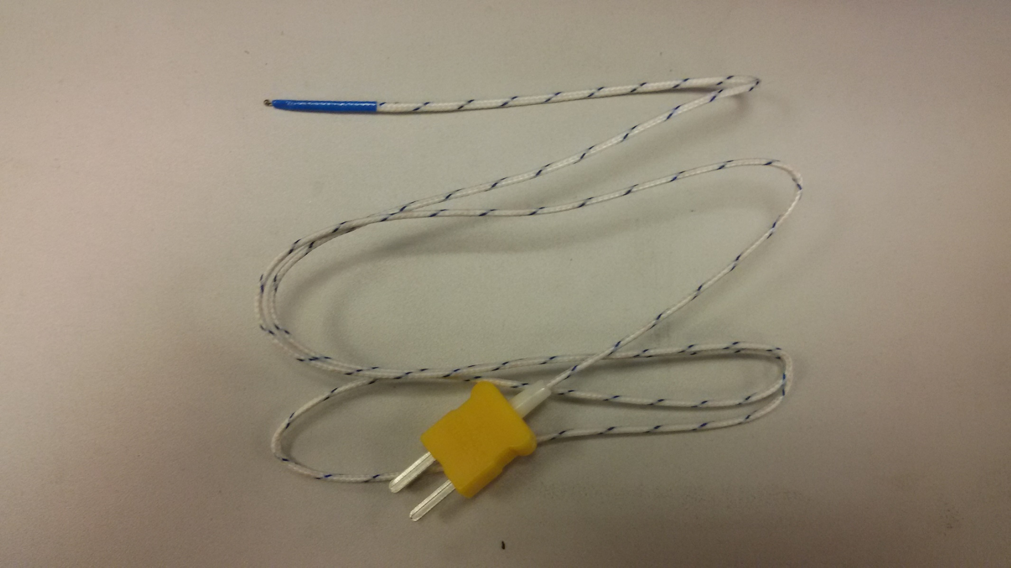

Figure 44: Thermocouple 1

*The Figure shows the thermocouple used for the top and bottom solar cell measurement.*

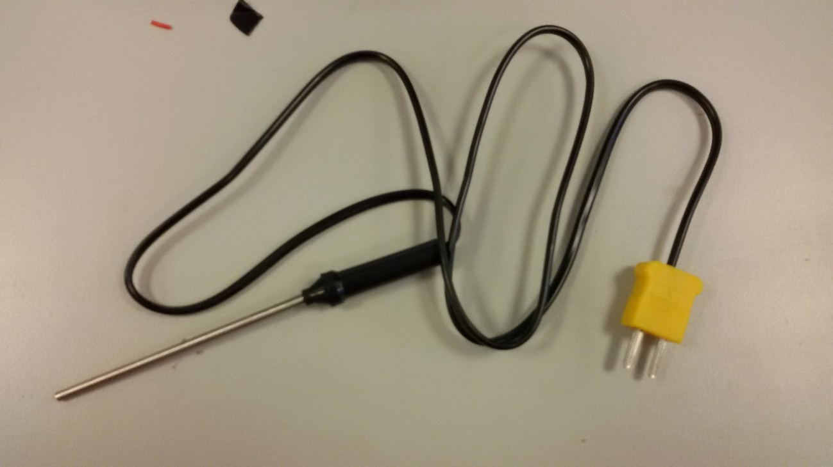

Figure 45: Thermocouple 2

*The Figure shows the thermocouple used for the flow temperature measurement.*

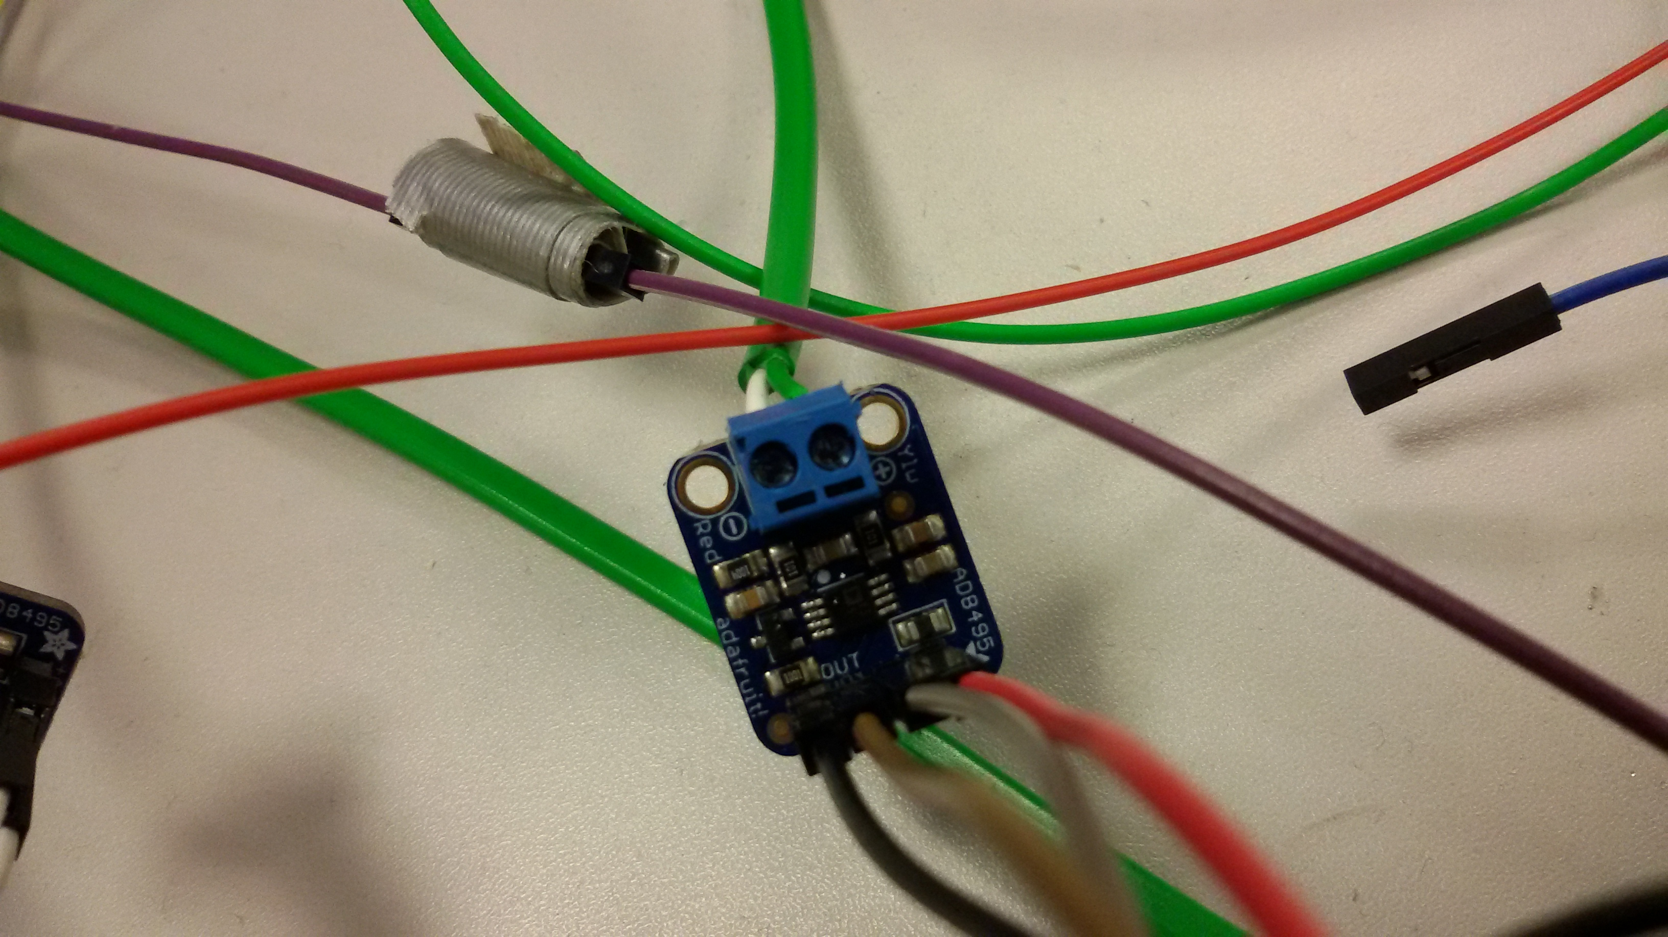

Figure 46: Thermocouple amplifier (not short-circuit)

*All four thermocouples were amplified by the depicted amplifier board.*

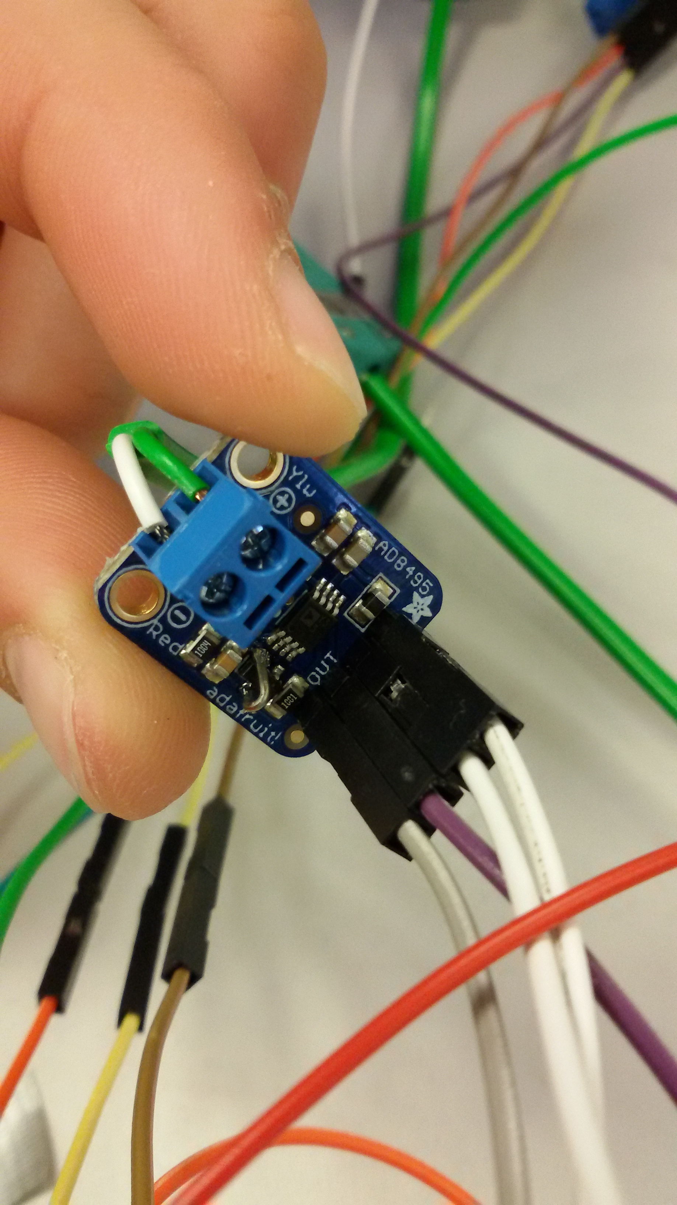

Figure 47: Short-circuit amplifier board

*The thermocouple amplifier board was short-circuit to prevent an offset value in the Formula 23.*